**1---------------------------------------------X-------------------------**

**What is a Spring Framework?**

* Spring is a powerful open source, application framework created to reduce the complexity of enterprise application development.
* It is light-weighted and loosely coupled.
* It has layered architecture, which allows you to select the components to use, while also providing a cohesive framework for J2EE application development.
* Spring framework is also called the framework of frameworks as it provides support to various other frameworks such as Struts, Hibernate, Tapestry, EJB, JSF etc.

**2)------------------------------------------------------X----------------------------------**

**List the advantages of Spring Framework.**

* Because of Spring Frameworks layered architecture, you can use what you need and leave which you don’t.
* Spring Framework enables POJO (Plain Old Java Object) Programming which in turn enables continuous integration and testability.
* JDBC is simplified due to Dependency Injection and Inversion of Control.
* It is open-source and has no vendor lock-in.

3**)------------------------------------------------------------X-----------------------------------**

**What are the different features of Spring Framework?**

Following are some of the major features of Spring Framework :

* **Lightweight:** Spring is lightweight when it comes to size and transparency.
* **Inversion of control (IOC):** The objects give their dependencies instead of creating or looking for dependent objects. This is called Inversion Of Control.
* **Aspect oriented Programming (AOP):** Aspect oriented programming in Spring supports cohesive development by separating application business logic from system services.
* **Container:**Spring Framework creates and manages the life cycle and configuration of the application objects.
* **MVC Framework:** Spring Framework’s MVC web application framework is highly configurable. Other frameworks can also be used easily instead of Spring MVC Framework.
* **Transaction Management:** Generic abstraction layer for transaction management is provided by the Spring Framework. Spring’s transaction support can be also used in container less environments.
* **JDBC Exception Handling:** The JDBC abstraction layer of the Spring offers an exception hierarchy, which simplifies the error handling strategy.

4)------------------------------------------------------X------------------------------------

**How many modules are there in Spring Framework and what are they?**

There are around 20 modules which are generalized into Core Container, Data Access/Integration, Web, AOP (Aspect Oriented Programming), Instrumentation and Test.

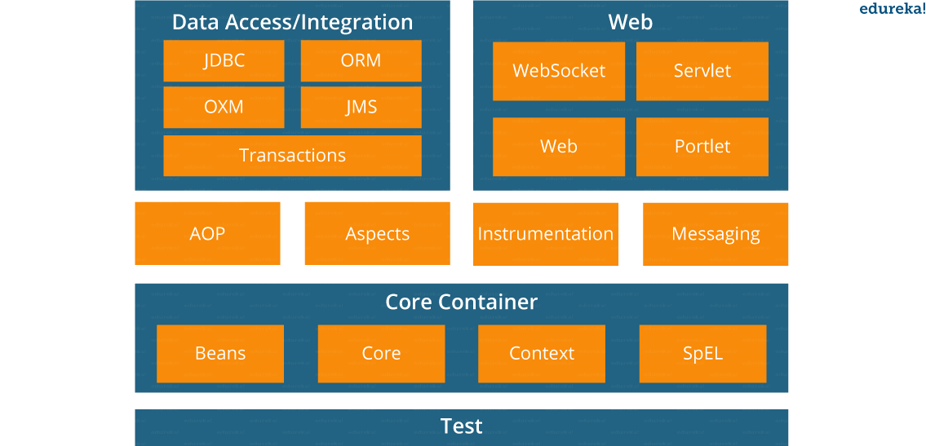

* **Spring Core Container –**This layer is basically the core of Spring Framework.It contains the following modules :

1. Spring Core
2. Spring Bean
3. SpEL (Spring Expression Language)
4. Spring Context

* **Data Access/Integration –**This layer provides support to interact with the database. It contains the following modules :

1. JDBC (Java DataBase Connectivity)
2. ORM (Object Relational Mapping)
3. OXM (Object XML Mappers)
4. JMS (Java Messaging Service)
5. Transaction

* **Web –**This layer provides support to create web application. It contains the following modules :

1. Web
2. Web – MVC
3. Web – Socket
4. Web – Portlet

* **Aspect Oriented Programming (AOP) –** In this layer you can use Advices, Pointcuts etc., to decouple the code.
* **Instrumentation –**This layer provides support to class instrumentation and classloader implementations.
* **Test –**This layer provides support to testing with JUnit and TestNG.

Few Miscellaneous modules are given below:

* **Messaging –**This module provides support for STOMP. It also supports an annotation programming model that is used for routing and processing STOMP messages from WebSocket clients.
* **Aspects –**This module provides support to integration with AspectJ.

5**)------------------------------------------------------X--------------------------------**

**What is a Spring configuration file?**

A Spring configuration file is an XML file. This file mainly contains the classes information. It describes how those classes are configured as well as introduced to each other. The XML configuration files, however, are verbose and more clean. If it’s not planned and written correctly, it becomes very difficult to manage in big projects.

6)---------------------------------------------------X----------------------------------------

**What are the different components of a Spring application?**

A Spring application, generally consists of following components:

* Interface: It defines the functions.
* Bean class: It contains properties, its setter and getter methods, functions etc.
* Spring Aspect Oriented Programming (AOP): Provides the functionality of cross-cutting concerns.
* Bean Configuration File: Contains the information of classes and how to configure them.
* User program: It uses the function.

7)---------------------------------------------X---------------------------------------------

**What are the various ways of using Spring Framework?**

Spring Framework can be used in various ways. They are listed as follows:

1. As a Full-fledged Spring web application.
2. As a third-party web framework, using Spring Frameworks middle-tier.
3. For remote usage.
4. As Enterprise Java Bean which can wrap existing POJOs (Plain Old Java Objects).

8)----------------------------------------------X------------------------------------------

**What is Spring IOC Container?**

**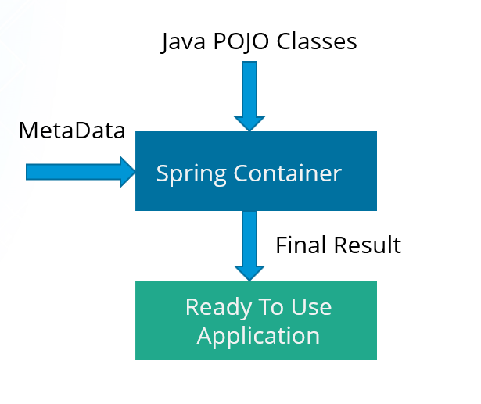**

At the core of the Spring Framework, lies the Spring container. The container creates the object, wires them together, configures them and manages their complete life cycle. The Spring container makes use of Dependency Injection to manage the components that make up an application. The container receives instructions for which objects to instantiate, configure, and assemble by reading the configuration metadata provided. This metadata can be provided either by XML, Java annotations or Java code.

9) -----------------------------------------------X--------------------------------------------

**What do you mean by Dependency Injection?**

In Dependency Injection, you do not have to create your objects but have to describe how they should be created. You don’t connect your components and services together in the code directly, but describe which services are needed by which components in the configuration file. The IoC container will wire them up together.

10) -----------------------------------------X-------------------------------------------------------------

**In how many ways can Dependency Injection be done?**

In general, dependency injection can be done in three ways, namely :

* Constructor Injection
* Setter Injection
* Interface Injection

In Spring Framework, only constructor and setter injections are used.

11)-------------------------------------------X------------------------------------------------------

**Differentiate between constructor injection and setter injection.**

Constructor Injection vs Setter Injection

|  |  |
| --- | --- |
| **Constructor Injection** | **Setter Injection** |
| There is no partial injection. | There can be partial injection. |
| It doesn’t override the setter property. | It overrides the constructor property. |
| It will create a new instance if any modification is done. | It will not create new instance if any modification is done. |
| It works better for many properties. | It works better for few properties. |

**12)------------------------------------------X-------------------------------------------**

**How many types of IOC containers are there in spring?**

1. **BeanFactory**: BeanFactory is like a factory class that contains a collection of beans. It instantiates the bean whenever asked for by clients.
2. **ApplicationContext**: The ApplicationContext interface is built on top of the BeanFactory interface. It provides some extra functionality on top BeanFactory.

13)---------------------------------------------X--------------------------------------------------------

**Differentiate between BeanFactory and ApplicationContext.**

BeanFactory vs ApplicationContext

|  |  |
| --- | --- |
| **BeanFactory** | **ApplicationContext** |
| It is an interface defined in org.springframework.beans.factory.**BeanFactory** | It is an interface defined in org.springframework.context.**ApplicationContext** |
| It uses Lazy initialization | It uses Eager/ Aggressive initialization |
| It explicitly provides a resource object using the syntax | It creates and manages resource objects on its own |
| It doesn’t supports internationalization | It supports internationalization |
| It doesn’t supports annotation based dependency | It supports annotation based dependency |

**14)---------------------------------------------X-------------------------------------**

**List some of the benefits of IoC.**

Some of the benefits of IoC are:

* It will minimize the amount of code in your application.
* It will make your application easy to test because it doesn’t require any singletons or JNDI lookup mechanisms in your unit test cases.
* It promotes loose coupling with minimal effort and least intrusive mechanism.
* It supports eager instantiation and lazy loading of the services.

**Spring Beans ---------------------------------------------**

**15)------------------------------------X------------------------**

**Explain Spring Beans?**

* They are the objects that form the backbone of the user’s application.
* Beans are managed by the Spring IoC container.
* They are instantiated, configured, wired and managed by a Spring IoC container
* Beans are created with the configuration metadata that the users supply to the container.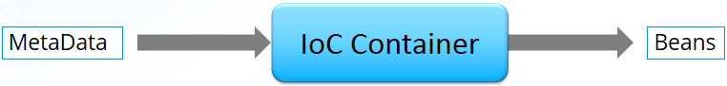

17)------------------------------------------------X--------------------------------------------

**17. How configuration metadata is provided to the Spring container?**

Configuration metadata can be provided to Spring container in following ways:

* **XML-Based configuration:**In Spring Framework, the dependencies and the services needed by beans are specified in configuration files which are in XML format. These configuration files usually contain a lot of bean definitions and application specific configuration options. They generally start with a bean tag. For example:

|  |  |
| --- | --- |
| 1  2  3 | <bean id="studentbean" class="org.edureka.firstSpring.StudentBean">   <property name="name" value="Edureka"></property>  </bean> |

* **Annotation-Based configuration**: Instead of using XML to describe a bean wiring, you can configure the bean into the component class itself by using annotations on the relevant class, method, or field declaration. By default, annotation wiring is not turned on in the Spring container. So, you need to enable it in your Spring configuration file before using it. For example:

|  |  |
| --- | --- |
| 1  2  3  4 | <beans>  <context:annotation-config/>  <!-- bean definitions go here -->  </beans> |

* **Java-based configuration:**The key features in Spring Framework’s new Java-configuration support are @Configuration annotated classes and @Bean annotated methods.

1. @Bean annotation plays the same role as the <bean/> element.
2. @Configuration classes allows to define inter-bean dependencies by simply calling other @Bean methods in the same class.

For example:

|  |  |
| --- | --- |
| 1  2  3  4  5  6  7 | @Configuration  public class StudentConfig  {  @Bean  public StudentBean myStudent()  { return new StudentBean(); }  } |

**---------------------------------------------X---------------------------------------------------**

**18. How many bean scopes are supported by Spring?**

The Spring Framework supports five scopes. They are:

* **Singleton:**This provides scope for the bean definition to single instance per Spring IoC container.
* **Prototype:**This provides scope for a single bean definition to have any number of object instances.
* **Request:**This provides scope for a bean definition to an HTTP-request.
* **Session:**This provides scope for a bean definition to an HTTP-session.
* **Global-session:**This provides scope for a bean definition to an Global HTTP-session.

The last three are available only if the users use a web-aware ApplicationContext.

**[mework Certification Training](https://www.edureka.co/spring-certification-course" \t "_blank)**

[--------------------------------------------------------X---------------------------------------Explore Curriculum](https://www.edureka.co/spring-certification-course" \t "_blank)

**19. What is the Bean life cycle in Spring Bean Factory Container?**

Bean life cycle in Spring Bean Factory Container is as follows:

1. The Spring container instantiates the bean from the bean’s definition in the XML file.
2. Spring populates all of the properties using the dependency injection, as specified in the bean definition.
3. The factory calls setBeanName() by passing the bean’s ID, if the bean implements the BeanNameAware interface.
4. The factory calls setBeanFactory() by passing an instance of itself, if the bean implements the BeanFactoryAware interface.
5. preProcessBeforeInitialization() methods are called if there are any BeanPostProcessors associated with the bean.
6. If an init-method is specified for the bean, then it will be called.
7. Finally, postProcessAfterInitialization() methods will be called if there are any BeanPostProcessors associated with the bean.

To understand it in better way check the below diagram:

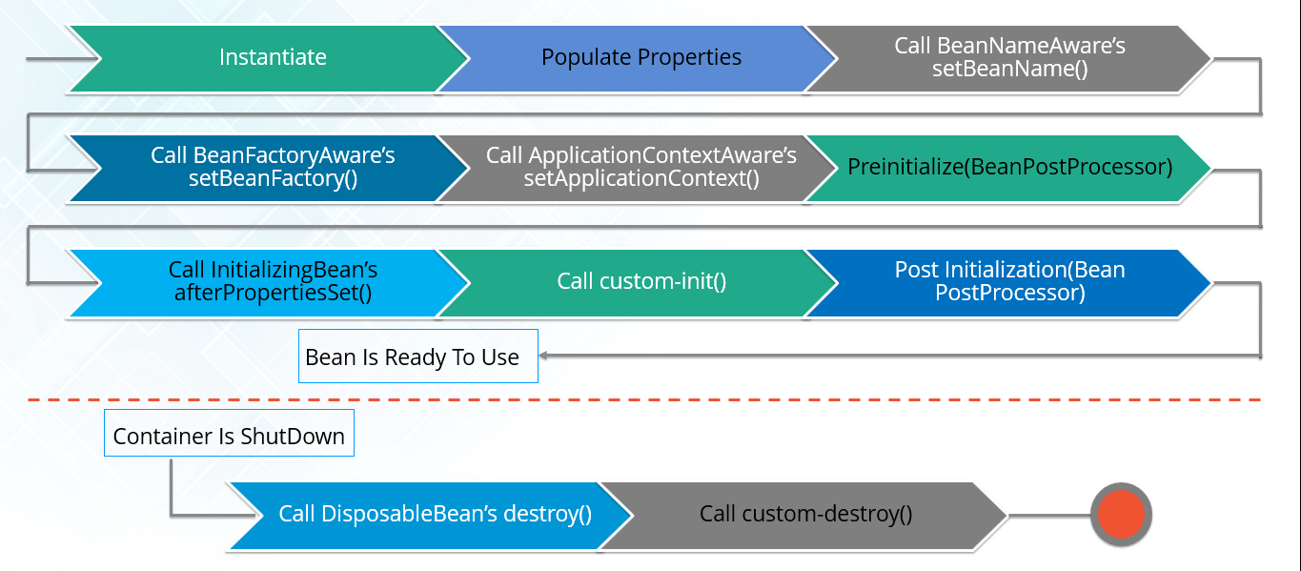

-------------------------------------------X---------------------------------------------------

**20. Explain inner beans in Spring.**

A bean can be declared as an inner bean only when it is used as a property of another bean. For defining a bean, the Spring’s XML based configuration metadata provides the use of <bean> element inside the <property> or <constructor-arg>. Inner beans are always anonymous and they are always scoped as prototypes. For example, let’s say we have one Student class having reference of Person class. Here we will be creating only one instance of Person class and use it inside Student.

Here’s a Student class followed by bean configuration file:

Student.java

|  |  |
| --- | --- |
| 1  2  3  4  5  6  7  8  9  10  11 | public class Student  {  private Person person;  //Setters and Getters  }  public class Person  {  private String name;  private String address;  //Setters and Getters  } |

studentbean.xml

|  |  |
| --- | --- |
| 1  2  3  4  5  6  7  8  9 | <bean id=“StudentBean" class="com.edureka.Student">  <property name="person">  <!--This is inner bean -->  <bean class="com.edureka.Person">  <property name="name" value=“Scott"></property>  <property name="address" value=“Bangalore"></property>  </bean>  </property>  </bean> |

**21)-------------------------------------------------------X----------------------------**

**Define Bean Wiring.**

When beans are combined together within the Spring container, it’s called wiring or bean wiring. The Spring container needs to know what beans are needed and how the container should use dependency injection to tie the beans together, while wiring beans.

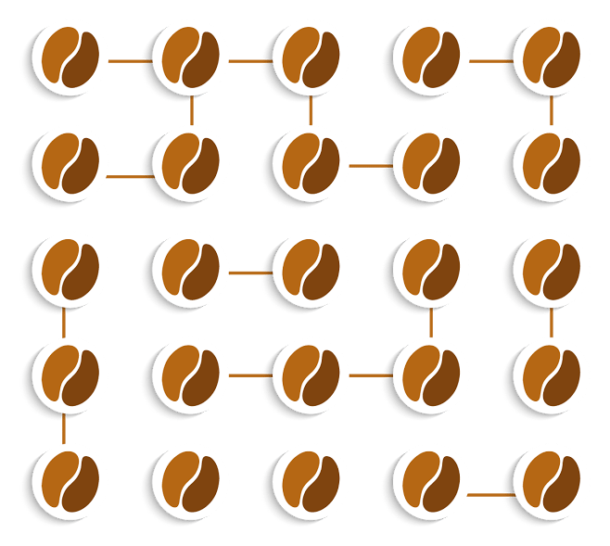

---------------------------------------------------------X----------------------------------------------

**22. What do you understand by auto wiring and name the different modes of it?**

The Spring container is able to autowire relationships between the collaborating beans. That is, it is possible to let Spring resolve collaborators for your bean automatically by inspecting the contents of the BeanFactory.  
Different modes of bean auto-wiring are:

1. **no:** This is default setting which means no autowiring. Explicit bean reference should be used for wiring.
2. **byName:** It injects the object dependency according to name of the bean. It matches and wires its properties with the beans defined by the same names in the XML file.
3. **byType:**It injects the object dependency according to type. It matches and wires a property if its type matches with exactly one of the beans name in XML file.
4. **constructor:**It injects the dependency by calling the constructor of the class. It has a large number of parameters.
5. **autodetect:**First the container tries to wire using autowire by *constructor*, if it can’t then it tries to autowire by *byType*.

**-**------------------------------------------------X---------------------------------------

**23. What are the limitations with auto wiring?**

Following are some of the limitations you might face with auto wiring:

* **Overriding possibility:**You can always specify dependencies using <constructor-arg> and <property> settings which will override autowiring.
* **Primitive data type:**Simple properties such as primitives, Strings and Classes can’t be autowired.
* **Confusing nature:**Always prefer using explicit wiring because autowiring is less precise.

In the next section, we will discuss on *Spring Annotations Interview Questions*.

**Spring Annotations – ---------------------------------------**

**24. What do you mean by Annotation-based container configuration?**

Instead of using XML to describe a bean wiring, the developer moves the configuration into the component class itself by using annotations on the relevant class, method, or field declaration. It acts as an alternative to XML setups. For example:

|  |  |
| --- | --- |
| 1  2  3  4  5  6  7 | @Configuration  public class AnnotationConfig  {  @Bean  public MyDemo myDemo()   { return new MyDemoImpll(); }  } |

**25)------------------------------------------X----------------------------------------------**

**How annotation wiring can be turned on in Spring?**

By default, Annotation wiring is not turned on in the Spring container. Thus, to use annotation based wiring we must enable it in our Spring configuration file by configuring **<context:annotation-config/>** element. For example:

|  |  |
| --- | --- |
| 1  2  3  4 | <beans xmlns="<a href="http://www.springframework.org/schema/beans">http://www.springframework.org/schema/beans</a>" xmlns:xsi="<a href="http://www.w3.org/2001/XMLSchema-instance">http://www.w3.org/2001/XMLSchema-instance</a>" xmlns:context="<ahref="http://www.springframework.org/schema/context">http://www.springframework.org/schema/context</a>">  <context:annotation-config/>  <beans ………… />  </beans> |

**26. ---------------------------------------------X-----------------------------------**

**What’s the difference between @Component, @Controller, @Repository & @Service annotations in Spring?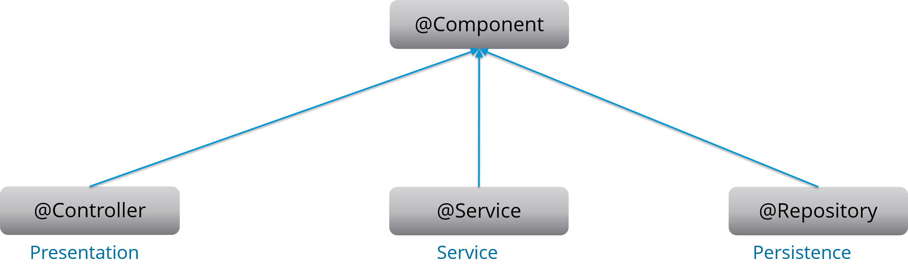**

**@Component:** This marks a java class as a bean. It is a generic stereotype for any Spring-managed component. The component-scanning mechanism of spring now can pick it up and pull it into the application context.

**@Controller:** This marks a class as a Spring Web MVC controller. Beans marked with it are automatically imported into the Dependency Injection container.

**@Service:** This annotation is a specialization of the component annotation. It doesn’t provide any additional behavior over the @Component annotation. You can use @Service over @Component in service-layer classes as it specifies intent in a better way.

**@Repository:** This annotation is a specialization of the @Component annotation with similar use and functionality. It provides additional benefits specifically for DAOs. It imports the DAOs into the DI container andmakes the unchecked exceptions eligible for translation into Spring DataAccessException.

**27. What do you understand by @Required annotation?**

@Required is applied to bean property setter methods. This annotation simply indicates that the affected bean property must be populated at the configuration time with the help of an explicit property value in a bean definition or with autowiring. If the affected bean property has not been populated, the container will throw BeanInitializationException.

For example:

|  |  |
| --- | --- |
| 1  2  3  4  5  6  7  8  9 | public class Employee  {  private String name;  @Required  public void setName(String name)  {this.name=name; }  public string getName()  { return name; }  } |

**28. What do you understand by @Autowired annotation?**

The **@Autowired** annotation provides more accurate control over where and how autowiring should be done. This annotation is used to autowire bean on the setter methods, constructor, a property or methods with arbitrary names or multiple arguments. By default, it is a type driven injection.

For Example:

|  |  |
| --- | --- |
| 1  2  3  4  5  6  7  8  9 | public class Employee  {  private String name;  @Autowired  public void setName(String name)  {this.name=name; }  public string getName()  { return name; }  } |

**29. What do you understand by @Qualifier annotation?**

When you create more than one bean of the same type and want to wire only one of them with a property  you can use the **@Qualifier** annotation along with **@Autowired** to remove the ambiguity by specifying which exact bean should be wired.

For example, here we have two classes, Employee and EmpAccount respectively. In EmpAccount, using @Qualifier its specified that bean with id emp1 must be wired.

Employee.java

|  |  |
| --- | --- |
| 1  2  3  4  5  6  7  8  9 | public class Employee  {  private String name;  @Autowired  public void setName(String name)  { this.name=name; }  public string getName()  { return name; }  } |

EmpAccount.java

|  |  |
| --- | --- |
| 1  2  3  4  5  6  7  8  9  10 | public class EmpAccount  {  private Employee emp;  @Autowired  @Qualifier(emp1)  public void showName()  {  System.out.println(“Employee name : ”+emp.getName);  }  } |

**30.  What do you understand by @RequestMapping annotation?**

@RequestMapping annotation is used for mapping a particular HTTP request method to a specific class/ method in controller that will be handling the respective request. This annotation can be applied at both levels:

* **Class level**: Maps the URL of the request
* **Method level**: Maps the URL as well as HTTP request method

Next section of Spring Interview Questions is on *Data Access*.

**Data Access – ----------------------------------------------**

**31. Describe Spring DAO support?**

The Data Access Object (DAO) support in Spring makes it easy to work with data access technologies like JDBC, Hibernate or JDO in a consistent way. This allows one to switch between the persistence technologies easily. It also allows you to code without worrying about catching exceptions that are specific to each of these technology.

------------------------------------X---------------------------------------------

**32. Name the exceptions thrown by the Spring DAO classes.**

See the below diagram, it depicts all the Spring DAO classes in the hierarchical order.

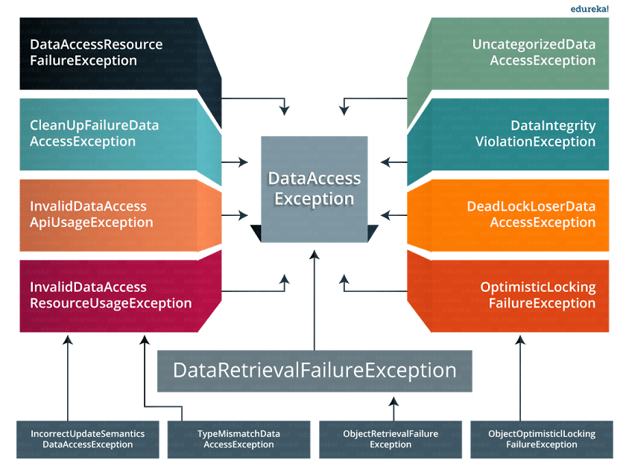

-------------------------------------------X-----------------------------------------

**33.  Which classes are present in spring JDBC API?**

Classes present in JDBC API are as follows:

1. JdbcTemplate
2. SimpleJdbcTemplate
3. NamedParameterJdbcTemplate
4. SimpleJdbcInsert
5. SimpleJdbcCall

--------------------------------------------------X--------------------------------------

**34. What are the ways by which Hibernate can be accessed using Spring?**

There are two ways by which we can access Hibernate using Spring:

1. Inversion of Control with a Hibernate Template and Callback
2. Extending HibernateDAOSupport and Applying an AOP Interceptor node

**35. Name the types of transaction management that Spring supports.**

Two types of transaction management are supported by Spring. They are:

1. **Programmatic transaction management:**In this, the transaction is managed with the help of programming. It provides you extreme flexibility, but it is very difficult to maintain.
2. **Declarative transaction management:**In this, the transaction management is separated from the business code. Only annotations or XML based configurations are used to manage the transactions.

**36. What are the different ORM’s supported by Spring?**

Different ORM’s supported by Spring are depicted via the below diagram:

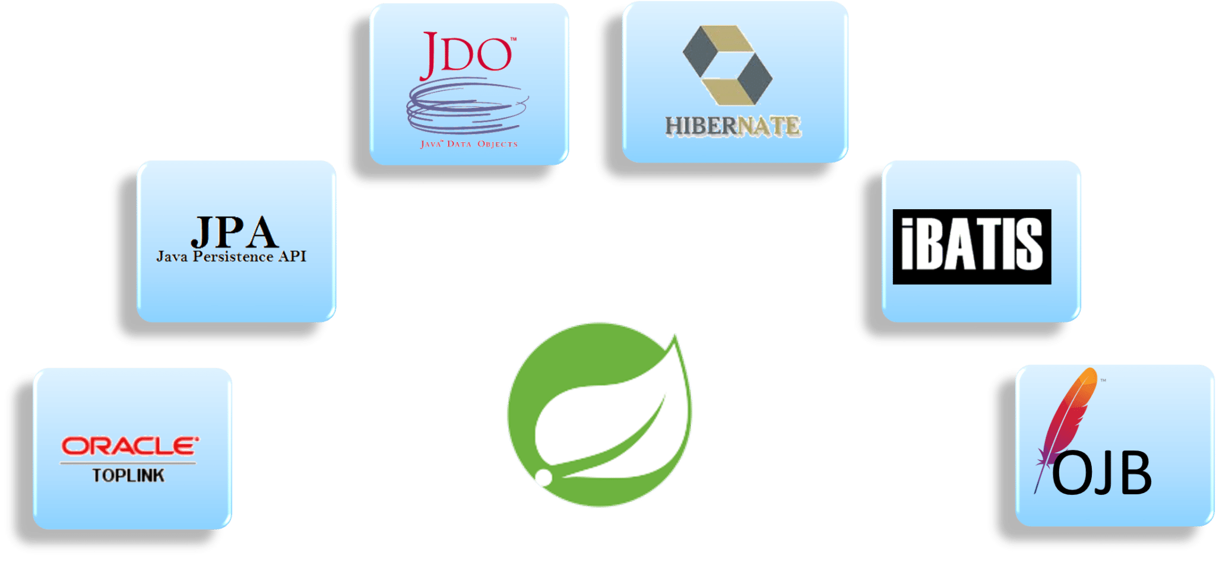---------------------------------------AOP------------------------------------------

**Aspect Oriented Programming (AOP) – Spring Interview Questions**

**37. Describe AOP.**

Aspect-oriented programming or AOP is a programming technique which allows programmers to modularize crosscutting concerns or behavior that cuts across the typical divisions of responsibility. Examples of cross-cutting concerns can be logging and transaction management. The core of AOP is an *aspect*. It encapsulates behaviors that can affect multiple classes into reusable modules.

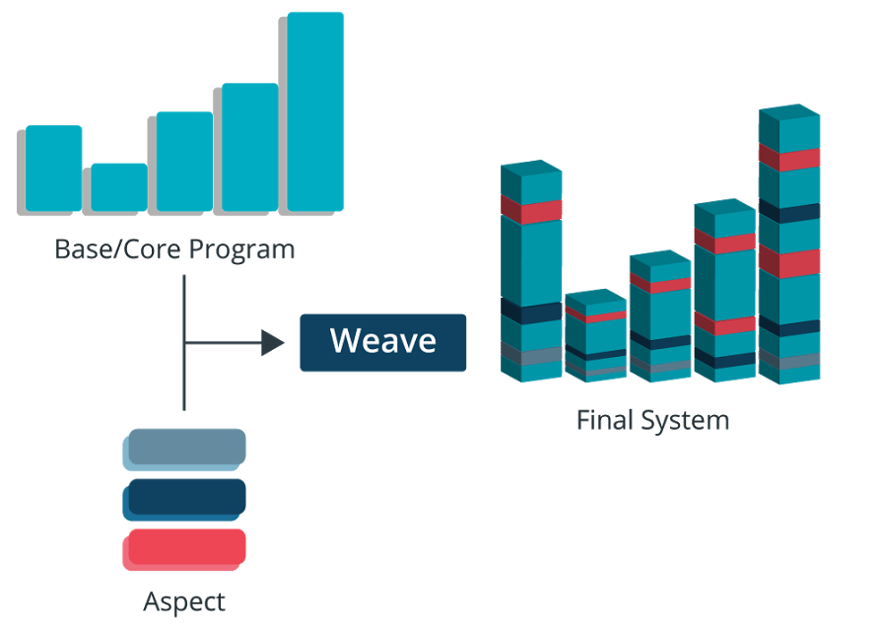

-------------------------------X-----------------------------------------

**38. What do you mean by Aspect?**

Aspect is a modularization of concern which cuts across multiple objects. Transaction management is a good example of a crosscutting concern in J2EE applications. Aspects are implemented using regular classes or regular classes annotated with the @Aspect annotation in Spring Framework.

-----------------------------------------X------------------------------------------------------

**39. Explain JoinPoint.**

A point during the execution of a program is called JoinPoint, such as the execution of a method or the handling of an exception. In Spring AOP, a joinpoint always represents a method execution.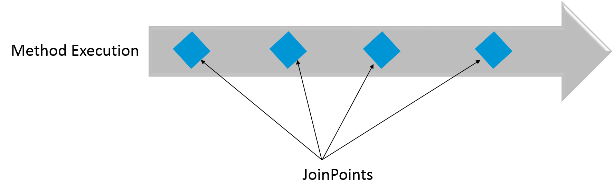

----------------------------------------X---------------------------------------------

**40. What is an Advice?**

An Action taken by an aspect at a particular joinpoint is known as an Advice. Spring AOP uses an advice as an interceptor, maintaining a chain of interceptors “around” the join point.

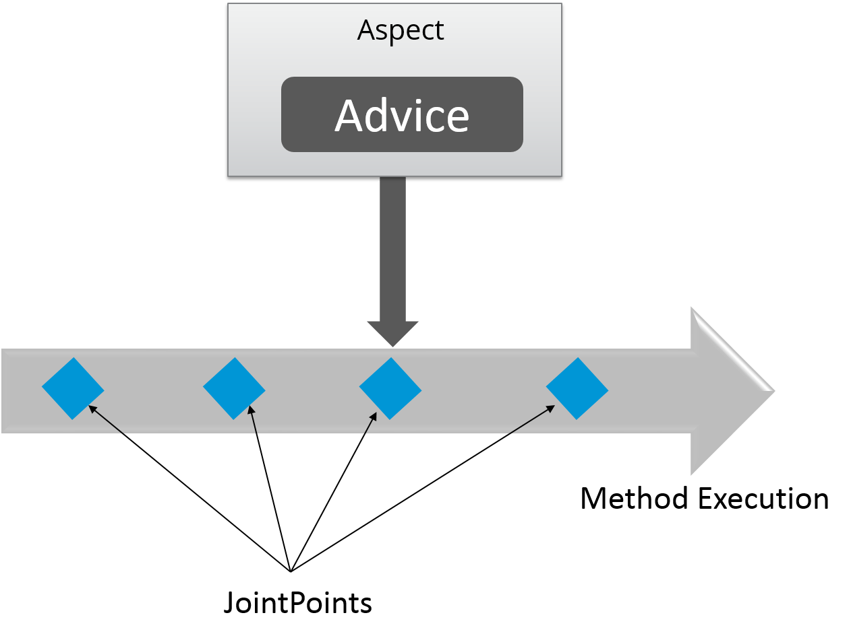

-------------------------------------------------------X-----------------------------------

**41. What are the different types of Advices?**

Different types of Advices in Spring AOP are:

1. **Before:** These types of advices execute before the joinpoint methods and are configured using **@Before**annotation mark.
2. **After returning:**These types of advices execute after the joinpoint methods completes executing normally and are configured using @AfterReturning annotation mark.
3. **After throwing:** These types of advices execute only if joinpoint method exits by throwing an exception and are configured using @AfterThrowing annotation mark.
4. **After (finally):**These types of advices execute after a joinpoint method, regardless of the method’s exit whether normally or exceptional return and are configured using @After annotation mark.
5. **Around:**These types of advices execute before and after a joinpoint and are configured using @Around annotation mark.

--------------------------------------X---------------------------------------

**42. Point out the difference between concern and cross-cutting concern in Spring AOP?**

* The concern is the behavior we want to have in a particular module of an application. It can be defined as a functionality we want to implement.
* The cross-cutting concern is a concern which is applicable throughout the application. This affects the entire application. For example, logging, security and data transfer are the concerns needed in almost every module of an application, thus they are the cross-cutting concerns.

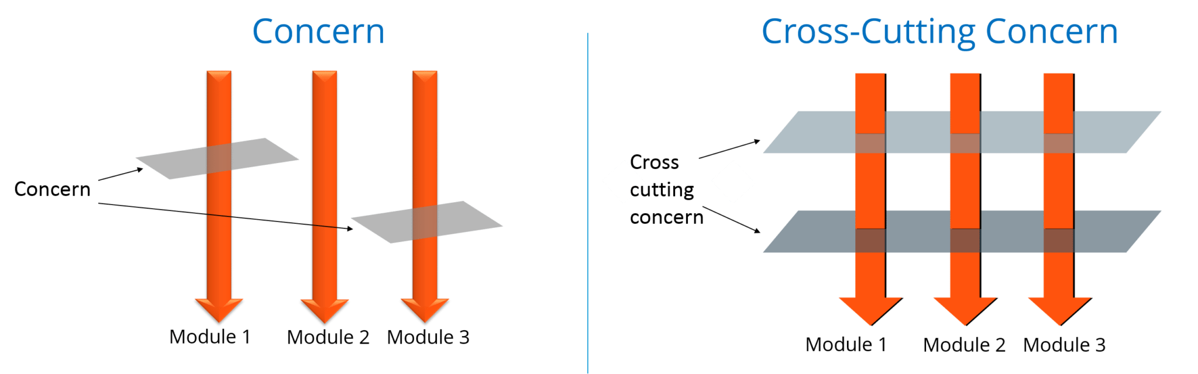

------------------------------------X-------------------------------------------

**43. What are the different AOP implementations?**

Different AOP implementations are depicted by the below diagram:

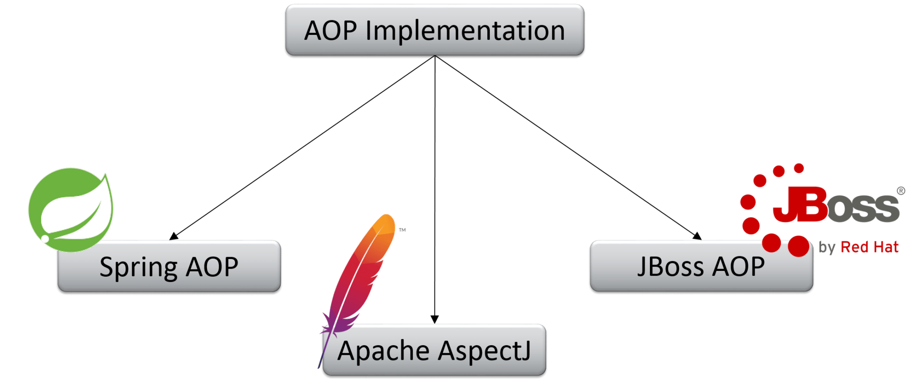

----------------------------------X-------------------------------------------

**44. What are the difference between Spring AOP and AspectJ AOP?**

Spring AOP vs AspectJ AOP

|  |  |
| --- | --- |
| **Spring AOP** | **AspectJ AOP** |
| Runtime weaving through proxy is done | Compile time weaving through AspectJ Java tools is done |
| It supports only method level PointCut | It suports field level Pointcuts |
| It is DTD based | It is schema based and Annotation configuration |

**---------------------------------------------------X-------------------------------------**

**45. What do you mean by Proxy in Spring Framework?**

An object which is created after applying advice to a target object is known as a Proxy. In case of client objects the target object and the proxy object are the same.

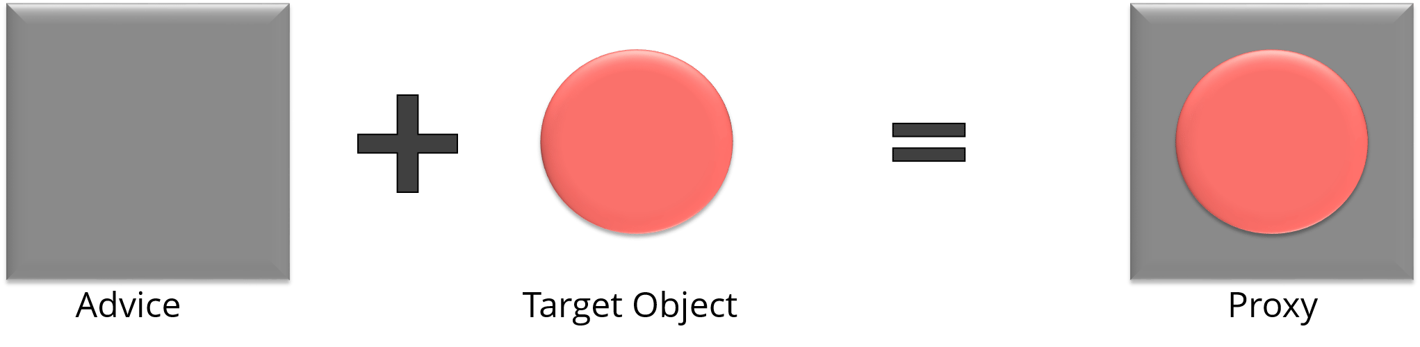

**46. In Spring, what is Weaving?**

The process of linking an aspect with other application types or objects to create an advised object is called Weaving. In Spring AOP, weaving is performed at runtime. Refer the below diagram:

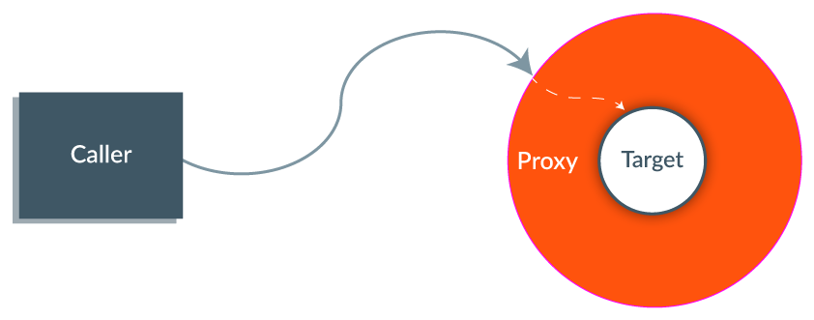

----------------------MVC------------------------------------------------

**MVC (Model-View-Controller) – -------------------------**

**47. What do you mean by Spring MVC framework?**

The Spring web MVC framework provides model-view-controller architecture and ready to use components that are used to develop flexible and loosely coupled web applications. The MVC pattern helps in separating the different aspects of the application like input logic, business logic and UI logic, while providing a loose coupling between all these elements.

**48. Describe DispatcherServlet.**

The DispatcherServlet is the core of Spring Web MVC framework. It handles all the HTTP requests and responses. The DispatcherServlet receives the entry of handler mapping from the configuration file and forwards the request to the controller. The controller then returns an object of Model And View. The DispatcherServlet checks the entry of view resolver in the configuration file and calls the specified view component.

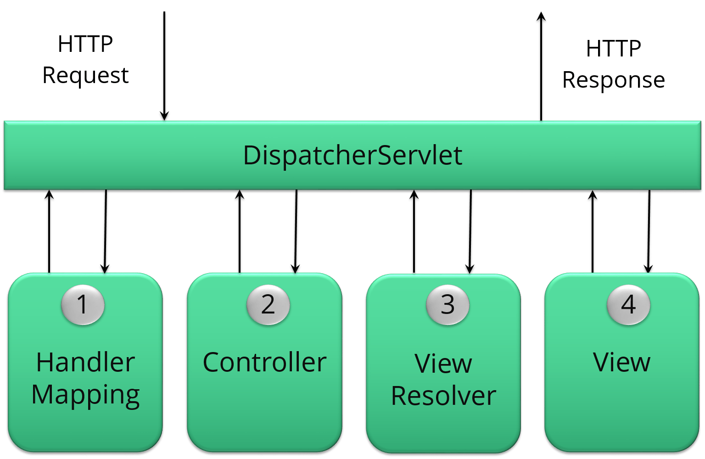

----------------------------------------------X---------------------------------------------

**49. Explain WebApplicationContext.**

The WebApplicationContext is an extension of the plain ApplicationContext. It has some extra features that are necessary for web applications. It differs from a normal ApplicationContext in terms of its capability of resolving themes and in deciding which servlet it is associated with.

----------------------------------X----------------------------------------

**50. In Spring MVC framework, what is controller?**

Controllers provide access to the application behavior. These behaviors are generally defined through a service interface. Controllers interpret the user input and transform it into a model which is represented to the user by the view. In Spring, controller is implemented in a very abstract way. It also enables you to create a wide variety of controllers.

-------------------------------------------------X-----------------------------------------------------

**Question 1: What is IOC or inversion of control?**([answer](http://javarevisited.blogspot.com/2012/12/inversion-of-control-dependency-injection-design-pattern-spring-example-tutorial.html))

Answer: This *Spring interview question* is the first step towards the Spring framework and many interviewers start Spring interviews from this question. As the name implies **Inversion of the control** means now we have inverted the control of creating the object from our own using a new operator to container or framework.  
  
Now it’s the responsibility of the container to create an object as required. We maintain one XML file where we configure our components, services, all the classes, and their property. We just need to mention which service is needed by which component and container will create the object for us.  
  
This concept is known as [dependency injection](http://javarevisited.blogspot.com/2013/06/spring-helloworld-example-in-java-using-3.0-dependency-injection.html) because all object dependency (resources) is injected into it by the framework.

Example:

<bean id="createNewStock"

**class**="springexample.stockMarket.CreateNewStockAccont">

<**property** name="newBid"/>

</**bean**>

* In this example, the CreateNewStockAccont class contains the getter and setter for newBid, and the container will instantiate newBid and set the value automatically when it is used. This whole process is also called wiring in Spring and by using [annotations](http://www.java67.com/2018/11/top-10-spring-framework-annotations-for-java-developers.html) it can be done automatically by Spring, referred to as auto-wiring of beans in Spring.

----------------------------------------------Bean-------------------------------------------

**Question 2: Explain the Spring Bean-LifeCycle.**

Ans: Spring framework is based on IOC so we call it an IOC container also So Spring beans reside inside the IOC container. Spring beans are nothing but Plain old java objects (POJO).

The following steps explain their life cycle inside the container.

1. The container will look at the bean definition inside the configuration file (e.g. bean.xml).

2 using reflection container will create the object and if any property is defined inside the bean definition then it will also be set.

3. If the bean implements the BeanNameAware interface, the factory calls setBeanName() passing the bean’s ID.  
  
4. If the bean implements the BeanFactoryAware interface, the factory calls setBeanFactory(), passing an instance of itself.  
  
5. If there are any BeanPostProcessors associated with the bean, their post- ProcessBeforeInitialization() methods will be called before the properties for the Bean are set.

6. If an init() method is specified for the bean, it will be called.  
7. If the Bean class implements the DisposableBean interface, then the destroy() method will be called when the Application no longer needs the bean reference.

8. If the Bean definition in the Configuration file contains a 'destroy-method' attribute, then the corresponding method definition in the Bean class will be called.  
  
These were just some of the Spring Fundamentals I can cover here if you are interested to learn more I suggest you take a look at [**Spring Master Class - Beginner to Expert**](https://click.linksynergy.com/fs-bin/click?id=JVFxdTr9V80&subid=0&offerid=323058.1&type=10&tmpid=14538&RD_PARM1=https%3A%2F%2Fwww.udemy.com%2Fspring-tutorial-for-beginners%2F), an end-to-end course to learn Spring.

[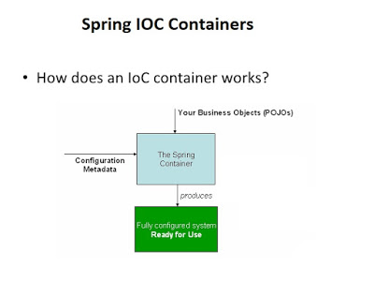](https://click.linksynergy.com/fs-bin/click?id=JVFxdTr9V80&subid=0&offerid=323058.1&type=10&tmpid=14538&RD_PARM1=https://www.udemy.com/spring-tutorial-for-beginners/)

**Question 3: What is Bean Factory, have you used XMLBeanFactory?**

Ans: BeanFactory is a factory Pattern that is based on IOC [design principles](http://javarevisited.blogspot.sg/2012/03/10-object-oriented-design-principles.html).it is used to make a clear separation between application configuration and dependency from actual code. The XmlBeanFactory is one of the implementations of Bean Factory which we have used in our project.  
  
The **org.springframework.beans.factory.xml.XmlBeanFactory is used to create bean instances defined in our XML file.**

BeanFactory **factory** = **new** XmlBeanFactory(**new** FileInputStream("beans.xml"));

Or

ClassPathResource resorce = **new** ClassPathResource("beans.xml");

XmlBeanFactory **factory** = **new** XmlBeanFactory(resorce);

**Question 4: What are the difference between BeanFactory and ApplicationContext in Spring?**([answer](http://javarevisited.blogspot.com/2012/11/difference-between-beanfactory-vs-applicationcontext-spring-framework.html))

Answer: This one is a very popular Spring interview question and often asks in an entry-level interview. ApplicationContext is the preferred way of using spring because of the functionality provided by it and the interviewer wanted to check whether you are familiar with it or not.

|  |  |
| --- | --- |
| **ApplicationContext.** | **BeanFactory** |
| Here we can have more than one config files possible | In this only one config file or .xml file |
| Application contexts can publish events to beans that are registered as listeners | Don't support. |
| Support internationalization (I18N) messages | It’s not |
| Support application life-cycle events, and validation. | Doesn’t support. |
| Supports many enterprise services such as JNDI access, EJB integration, remoting | Doesn’t support. |

**Question 5: What is AOP?**

Answer: The core construct of AOP is the aspect, which encapsulates behaviors affecting multiple classes into reusable modules. AOP is a programming technique that allows a developer to modularize crosscutting concerns, that cut across the typical divisions of responsibility, such as **logging and transaction management.**  
  
Spring AOP, aspects are implemented using regular classes or regular classes annotated with the @Aspect annotation. You can also check out these [**30+ Spring MVC interview questions**](http://java67.com/2012/08/spring-interview-questions-answers.html) for more focus on Java web development using the Spring MVC framework.

**Question 6: Explain Advice?**

Answer: It’s an implementation of aspect; advice is inserted into an application at join points. Different types of advice include “around,” “before” and “after” advice

**Question 7: What are the joint Point and point cut?**

Ans: This is not really a spring interview question I would say an AOP one.  Similar to [Object-oriented programming](http://javarevisited.blogspot.sg/2012/03/10-object-oriented-design-principles.html), AOP is another popular programming concept that complements OOPS. A join point is an opportunity within the code for which we can apply an aspect. In Spring AOP, a join point always represents a method execution.

**Pointcut**: a predicate that matches join points. A pointcut is something that defines what join-points advice should be applied.  
  
If you need more Spring AOP questions then you can also check out my article about [**17 Spring AOP Interview Questions with Answers**](https://javarevisited.blogspot.com/2021/03/spring-aop-interview-questions-answers.html#axzz6nwXUSoGH) for Java developers.   
  
  
  
**Question 8: Difference between the setter and constructor injection in Spring?** ([answer](http://javarevisited.blogspot.com/2012/11/difference-between-setter-injection-vs-constructor-injection-spring-framework.html))  
Setter injection is more flexible than constructor injection because you must remember the type and order of the constructor parameters. Also, constructor injection is generally used to inject the mandatory dependency, while setter can be used to inject the optional dependency.

**-----------------------------------------X----------------------------------------------------------**

**Question 9: Difference between Factory Pattern and Dependency Injection in Java?**([answer](http://javarevisited.blogspot.com/2015/06/difference-between-dependency-injection.html))

Even though both allow you to reduce coupling in code, dependency injection is much more flexible and easier to test than Factory pattern.

---------------------------------------------------------X---------------------------------

**Questions 10. Difference between @Autowired and @ Inject annotation in Spring?** ([answer](https://javarevisited.blogspot.com/2017/04/difference-between-autowired-and-inject-annotation-in-spring-framework.html#axzz5nFQiRhkv))  
---------------------------------------------X------------------------------------

**Question 11: What are the different modules in spring?**

Answer: spring has seven core modules

1.      The Core container module

2.      Application context module

3.      AOP module (Aspect Oriented Programming)

4.      JDBC abstraction and DAO module

5.      O/R mapping integration module (Object/Relational)

6.      Web module

7.      MVC framework module

--------------------------------------------------MVC-----------------------------------------

* So far we have seen the Spring core interview questions and answers and now let's see some interview questions from Spring MVC,
* one of the most important parts of Spring farm work which allows you to develop web applications in Java using Model View Controller design pattern.

**Questions 12: What is the difference between @Controller and @RestController in Spring MVC?**([answer](http://javarevisited.blogspot.sg/2017/08/difference-between-restcontroller-and-controller-annotations-spring-mvc-rest.html))

* Even though both are used to indicate that a Spring bean is a Controller in Spring MVC setup, @RestController is better when you are developing [RESTful web services](https://javarevisited.blogspot.com/2018/02/top-5-restful-web-services-with-spring-courses-for-experienced-java-programmers.html) using the Spring MVC framework.
* It's a combination of @Controller + @ResponseBody annotation which allows the controller to directly write the response and bypassing the view resolution process, which is not required for RESTful web service.
* It also instructs DispatcherServlet to use different HttpMessageConverters to represent the response in the format client is expecting e.g. HttpMessageJackson2Convert to represent response in JSON format and JAXB based message converts to generate XML response.  
  [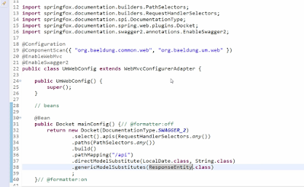](http://www.baeldung.com/rest-with-spring-course?utm_source=javarevisited&utm_medium=web&utm_campaign=rws&affcode=22136_bkwjs9xa)

------------------------------------------X------------------------------------------------

**Question 13: What is the difference between a singleton and a prototype bean?**

Ans:

* Basically, a bean has scopes which define their existence on the application.
* **Singleton:** means single bean definition to a single object instance per Spring IOC container.
* **Prototype**: means a single bean definition to any number of object instances.
* Whatever beans we defined in the spring framework are singleton beans.
* There is an attribute in the bean tag named ‘singleton’ if specified true then the bean becomes singleton and if set to false then the bean becomes a prototype bean.
* By default, it is set to true. So, all the beans in the spring framework are by default singleton beans.

**<bean id="createNewStock" class="springexample.stockMarket.CreateNewStockAccont"**

**singleton=”false”>**

**<property name="newBid"/>**

**</bean>**

------------------------------------------------X------------------------------------- **Question 14: What is the role of DispatcherServlet in Spring MVC?**([answer](http://www.java67.com/2017/06/what-is-use-of-dispatcherservlet-in-spring-mvc.html))

* The DispatcherServlet is very important from the Spring MVC perspective, it acts as a FrontController i.e. all requests pass through it. It is responsible for routing the request to the controller and view the resolution before sending the response to the client.
* When Controller returns a Model or View object, it consults all the view resolvers registered to find the correct type of ViewResolver which can render the response for clients.
* In the case of RESTful Web Services, the DispatcherServlet is also responsible for using HttpMessageConverter to represent the response in the JSON, XML, or TEXT format, depending on the content negotiation between Client and Server like if the client sends a request with HTTP accept header as "application/json" then DispatcherServlet will ask the HttpMessageJackson2Converter to convert the response into JSON format.

---------------------------------------------------------X------------------------------------------------------

**Question 15: How to call the stored procedure from Java using Spring Framework?** ([answer](http://javarevisited.blogspot.com/2013/04/spring-framework-tutorial-call-stored-procedures-from-java.html))  
  
**Question 16: How to Setup JDBC Database connection pool in Spring Web application?** ([answer](http://javarevisited.blogspot.com/2012/06/jdbc-database-connection-pool-in-spring.html))  
  
**Questions 17: Difference between @ReqeustParam and @PathVariable in Spring MVC?** ([answer](https://javarevisited.blogspot.com/2017/10/differences-between-requestparam-and-pathvariable-annotations-spring-mvc.html))  
  
**Questions 18: Difference between @Component, @Service, @Controller, and @Repositoring annotation in Spring MVC?** ([answer](https://javarevisited.blogspot.com/2017/11/difference-between-component-service.html))

------------------------------------------X--------------------------------------------

**Question 19: What type of transaction Management Spring support?**

Ans:

* Transaction management is critical in any application that will interact with the database.  
  The application has to ensure that the data is consistent and the integrity of the data is maintained.  Following two types of transaction management is supported by spring:

1. Programmatic transaction management

2. Declarative transaction management.

------------**Spring Security Interview Questions Answer---------------------------**

**20. How do you control the concurrent Active session using Spring Security? (**[**answer**](http://javarevisited.blogspot.sg/2012/03/spring-security-example-tutorial-how-to.html)**)**

* You can easily control How many active sessions a user can have with a Java application by using Spring Security.
* Apart from that Spring Security also provides the "remember me" feature which you can use to provide easier access for your users by remembering their login details on their personal computer

---------------------------------------X--------------------------------  
**21. How do you set up LDAP Authentication using Spring Security? (**[**answer**](http://javarevisited.blogspot.sg/2011/11/ldap-authentication-active-directory.html)**)**  
This is a very popular Spring Security interview question as Spring provides out-of-the-box support to connect Windows Active Directory for LDAP authentication and with few configurations in the Spring config file you can have this feature enabled.  
  
----------------------------------------------X--------------------------------------------------  
**22.  How to implement Role-Based Access Control (RBAC) using Spring Security?**([answer](http://javarevisited.blogspot.com/2013/07/role-based-access-control-using-spring-security-ldap-authorities-mapping-mvc.html))  
Spring Security provides a couple of ways to implement Role-based access control like by using GrantedAuthority.

-------------------------------X---------------------------------------------------------

**Why do we need Auto configuration?**

**Ans-**

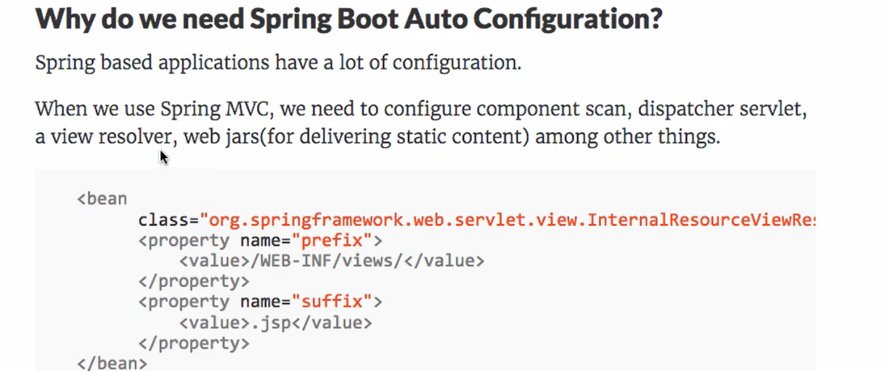

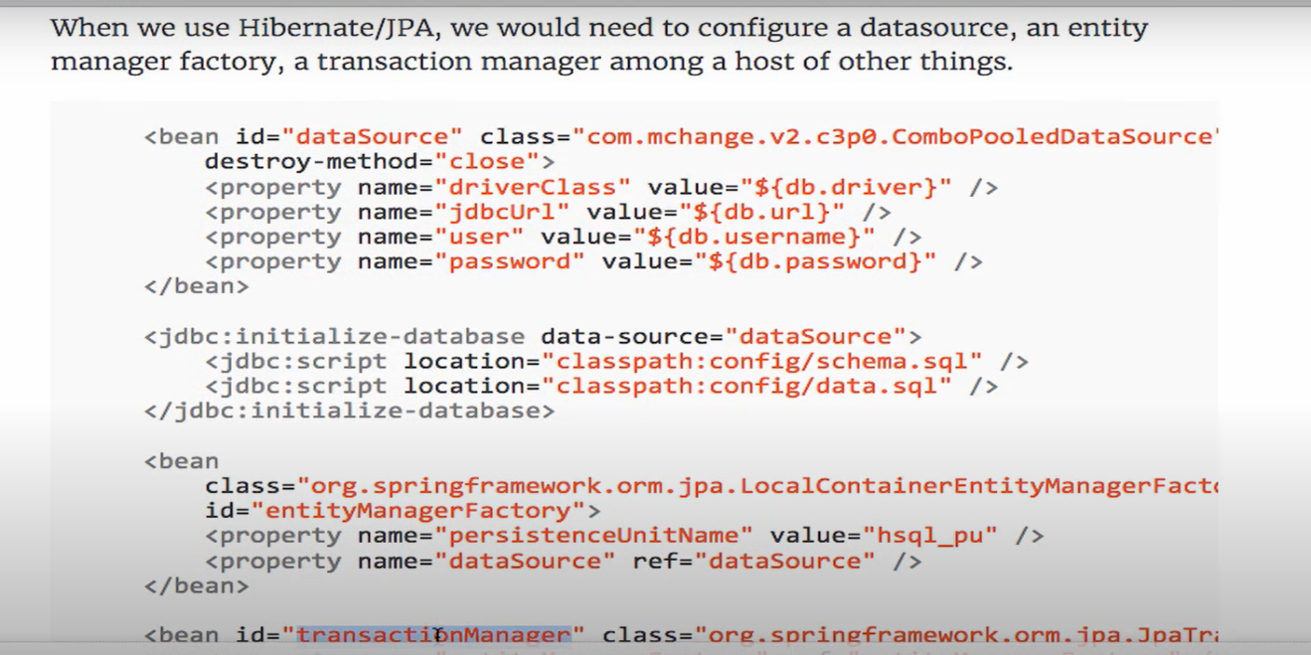

Application need standard dependency in mvc application. Which is overload

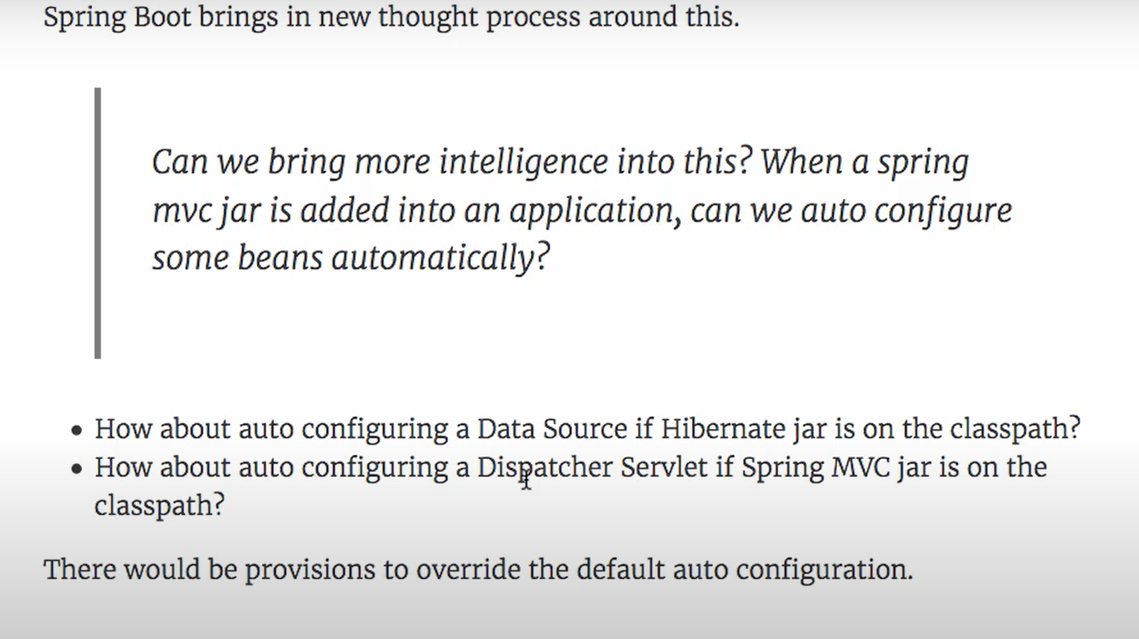

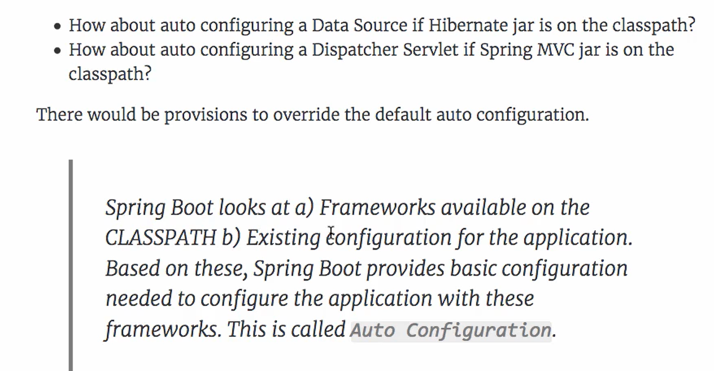

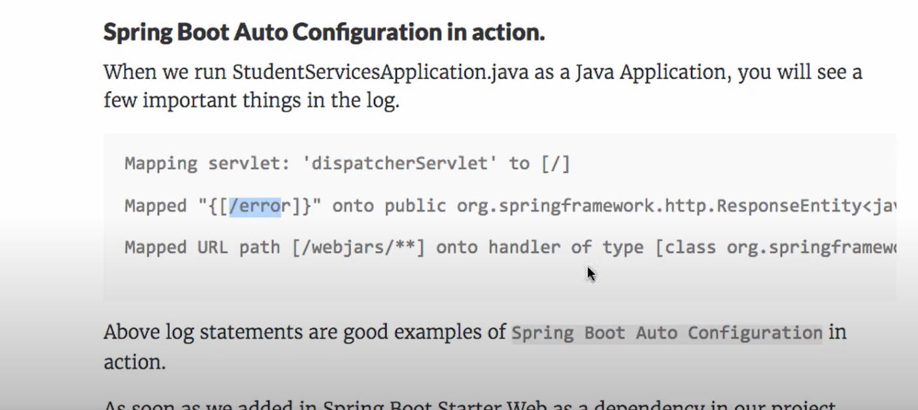

Spring auto configuration save our time from configuring above thing again and again and we can focus on application development

-----------------------------------------X------------------------------

**Where is spring Boot auto configuration is implemented?**

Ans-

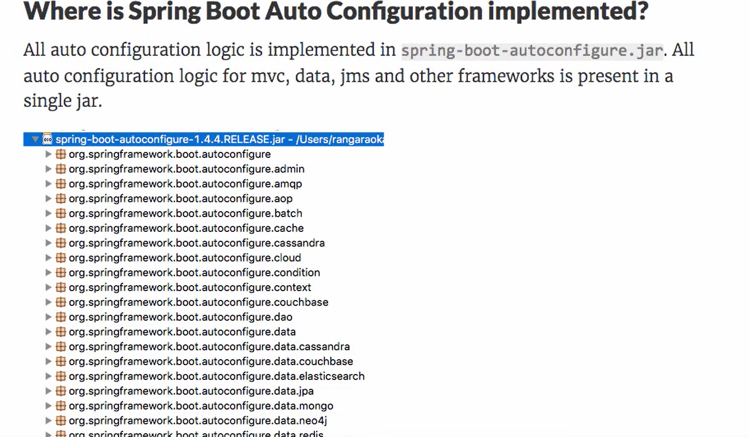

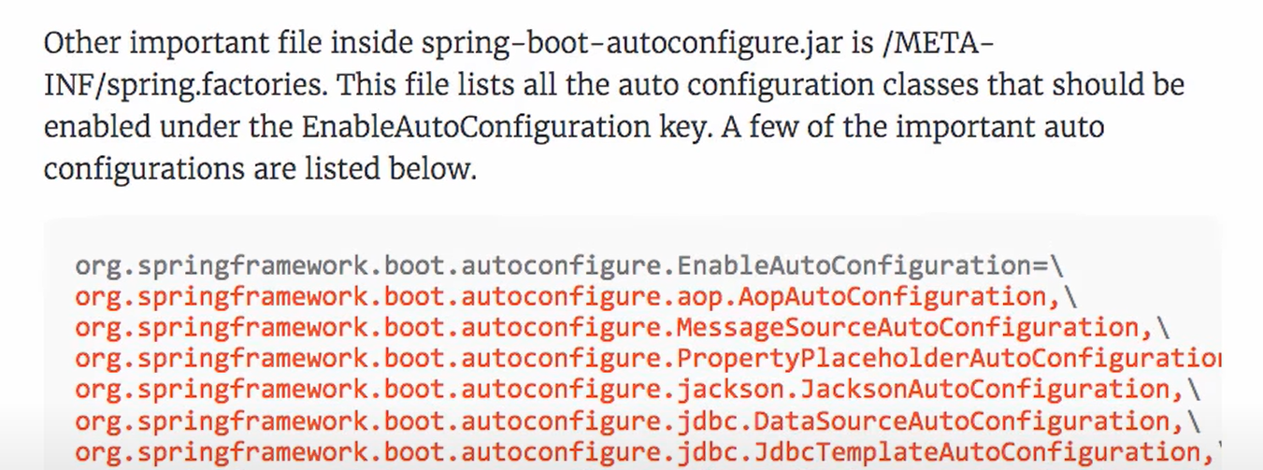

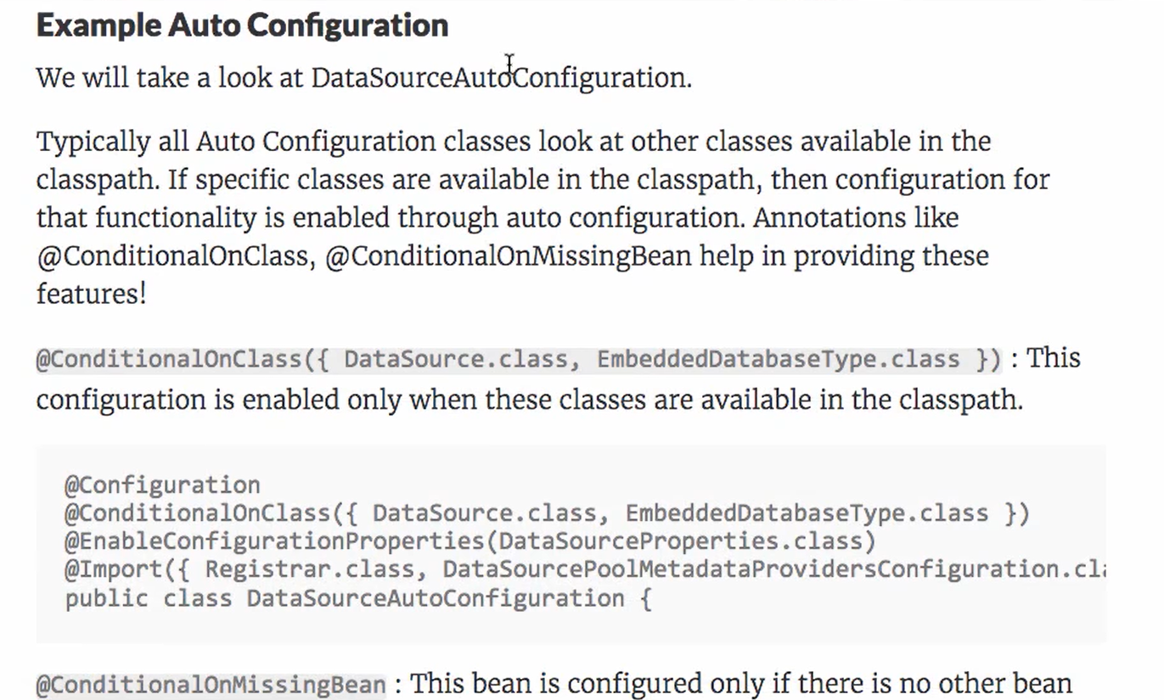

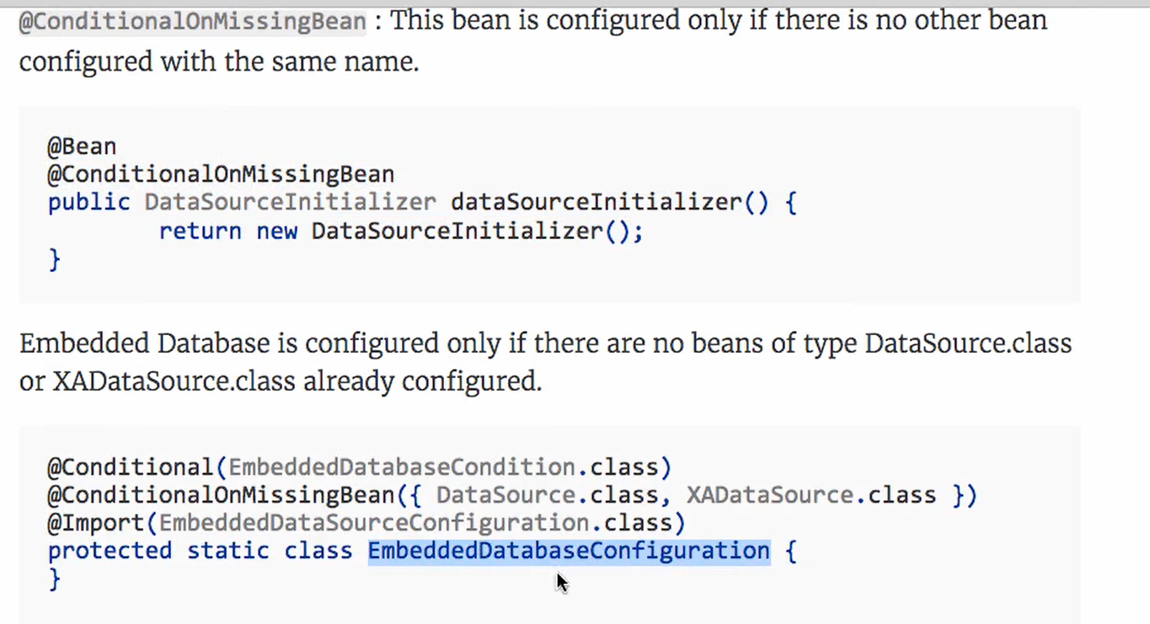

-----------------------------------------X-------------------------------------------

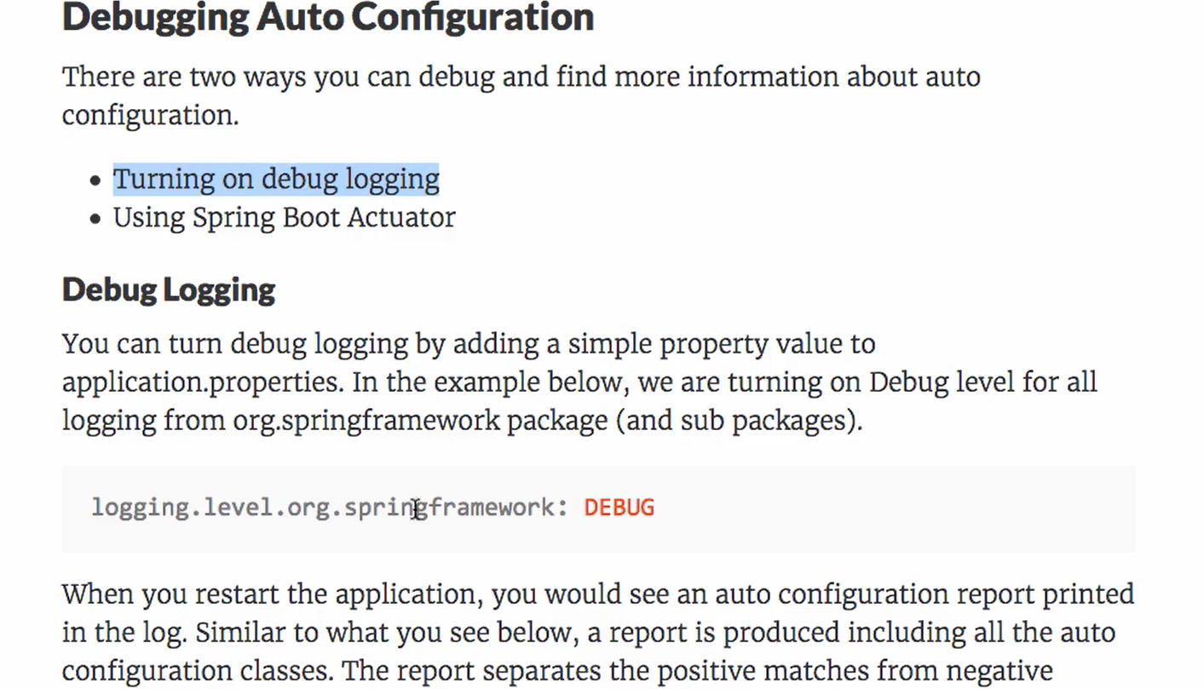

----------------------------------------------X---------------------------------

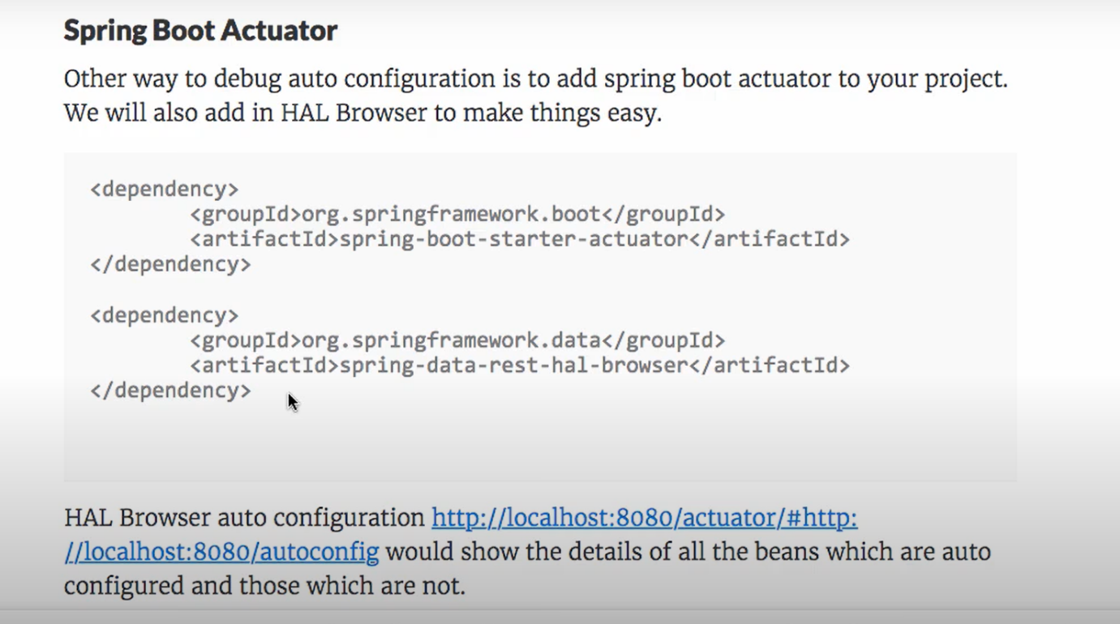

<http://localhost:8080/actuator/#http>

<http://localhost:8080/autoconfig>

----------------------Actuators--------------------------------------

* What are the two protocols you can use to access actuator endpoints?[http/jmx]
* What are the actuator endpoints that are provided out of the box?
* What value does Spring Boot Actuator provide?
* How do you create a custom metric?
* What is Health Indicator?

------------------------Demo- auto configuration--------------------------

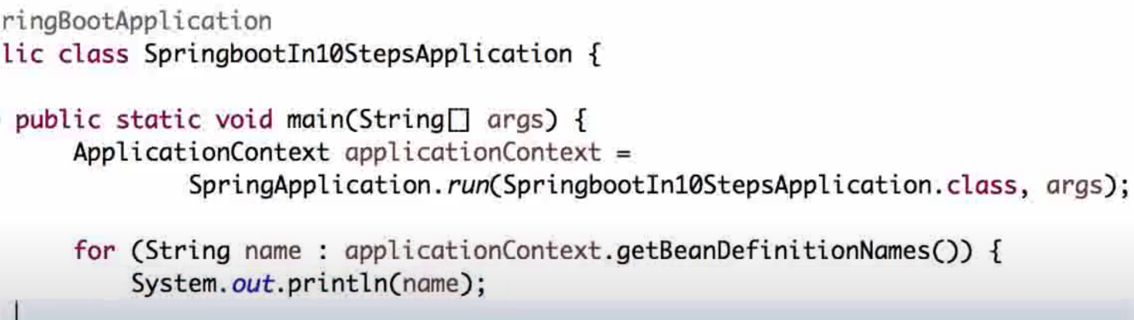

------------------------------X---------------------------------------------------

**How spring does auto configuration?**

Ans-

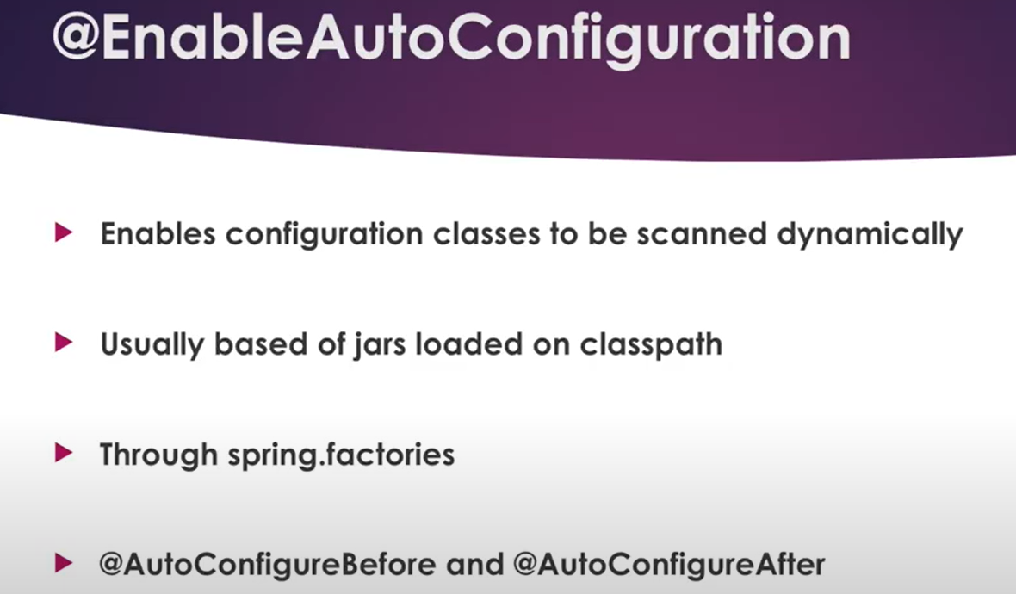

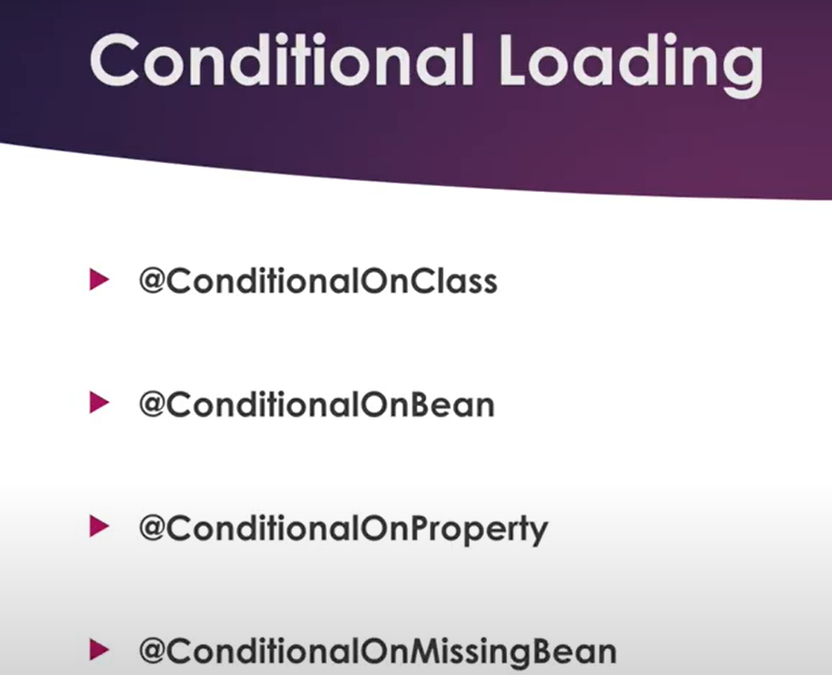

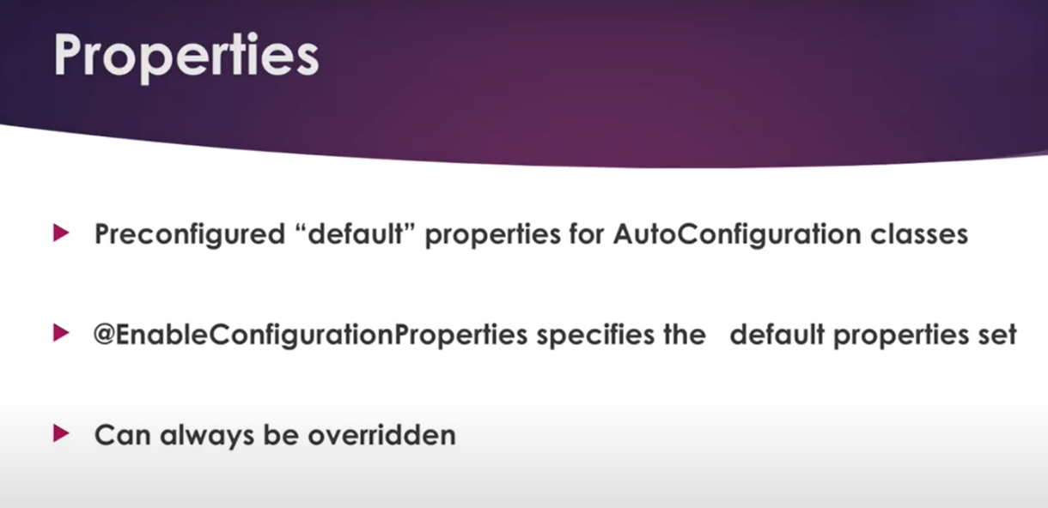

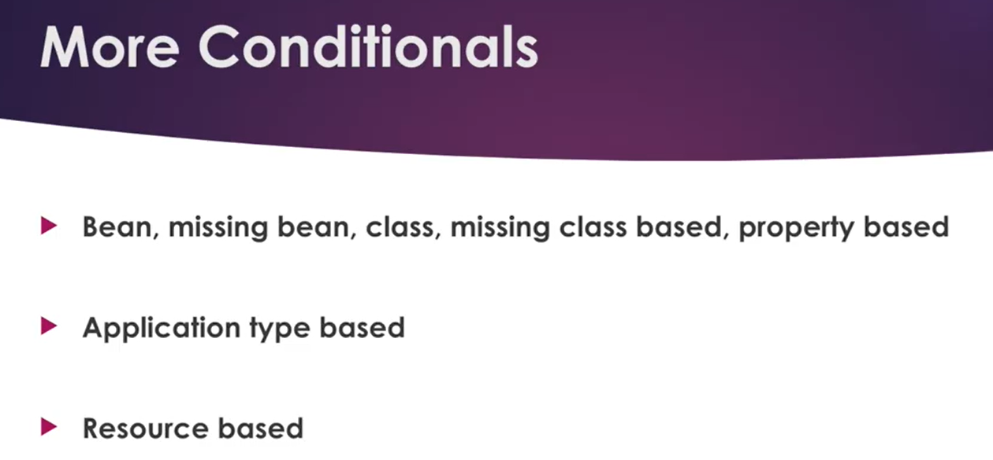

--------------------------------------X-----------------------------------------

**What is the use of @Conditional annotation in auto configuration?**

**Ans-**

* While developing Spring based applications we may come across a need to register beans conditionally.
* For example, you may want to register a DataSource bean pointing to the dev database while running application locally and point to a different production database while running in production.
* You can externalize the database connection parameters into the properties file and use the file appropriate for the environment, but you need to change the configuration whenever you need to point to a different environment and build the application.
* To address this problem, Spring 3.1 introduced the concept of **Profiles**. You can register multiple beans of the same type and associate them with one or more profiles.
* When you run the application you can activate the desired profiles and beans associated with the activated profiles, and only those profiles will be registered.

**@Configuration**

**public class AppConfig{**

**@Bean**

**@Profile("DEV")**

**public DataSource devDataSource() {}**

**@Bean**

**@Profile("PROD")**

**public DataSource prodDataSource() {}}**

* Then you can specify the active profile using System Property **-Dspring.profiles.active=DEV.**
* This approach works for simple cases like enable or disable bean registrations based on activated profiles.
* But if you want to register beans based on some conditional logic then the profiles approach itself is not sufficient.
* To provide more flexibility for registering Spring beans conditionally, Spring 4 introduced the concept of **@Conditional**.
* By using the **@Conditional** approach you can register a bean conditionally based on any arbitrary condition.

For example, you may want to register a bean when:

* A specific class is present in classpath
* A Spring bean of certain type doesn’t already register in ApplicationContext
* A specific file exists on a location
* A specific property value is configured in a configuration file
* A specific system property is present/absent

These are just a few examples only and you can have any condition you want.

Let us take a look at how Spring’s @Conditional works.

* Suppose we have a **UserDAO**interface with methods to get data from a data store. We have two implements of **UserDAO**interface namely **JdbcUserDAO**which talks to **MySQL**database and **MongoUserDAO**which talks to **MongoDB**.
* We may want to enable only one interface of **JdbcUserDAO**and **MongoUserDAO**based on a System Property, say **dbType**.
* If the application is started using **java -jar myapp.jar -DdbType=MySQL**, then we want to enable **JdbcUserDAO.** Otherwise, if the application is started using **java -jar myapp.jar -DdbType=MONGO**, we want to enable **MongoUserDAO**.
* Suppose we have a **UserDAO**bean and a **JdbcUserDAO**bean. The **MongoUserDAO**implementation is as follows:

------------------------------------------X------------------------------------------

**How to pass command line argument to spring boot application?**

Ans-

We can use command-line arguments to configure our application,

* override application properties
* pass custom arguments.

----------------------------X---------------------------------------

**What is difference between @profile and @Conditional?**

Ans-

* @Profile annotation is restricted to write conditional checking bases on predefine properties.
* @Condition annotation do not have that restriction.

------------------------------X----------------------------------------

### Q1. Why Should We Use Spring MVC?

**Spring MVC implements a clear separation of concerns that allows us to develop and unit test our applications easily**.

The concepts like:

* Dispatcher Servlet
* Controllers
* View Resolvers
* Views, Models
* ModelAndView
* Model and Session Attributes

are completely independent of each other, and they are responsible for one thing only.

Therefore, **MVC gives us quite big flexibility**. It's based on interfaces (with provided implementation classes), and we can configure every part of the framework by using custom interfaces.

**Another important thing is that we aren't tied to a specific view technology (for example, JSP), but we have the option to choose from the ones we like the most**.

Also, **we don't use Spring MVC only in web applications development but in the creation of RESTful web services as well**.

### ****Q2. What Is the Role of the****@Autowired****Annotation?****

**The @Autowired annotation can be used with fields or methods for injecting a bean by type**. This annotation allows Spring to resolve and inject collaborating beans into your bean.

-------------------------------------------X---------------------------

### Q3. Explain a Model Attribute

The @ModelAttribute annotation is one of the most important annotations in Spring MVC. **It binds a method parameter or a method return value to a named model attribute and then exposes it to a web view**.

If we use it at the method level, it indicates the purpose of that method is to add one or more model attributes.

On the other hand, when used as a method argument, it indicates the argument should be retrieved from the model. When not present, we should first instantiate it and then add it to the model. Once present in the model, we should populate the arguments fields from all request parameters that have matching names.

More about this annotation can be found in our [article related to the @ModelAttribute annotation](https://www.baeldung.com/spring-mvc-and-the-modelattribute-annotation).

---------------------------------X-----------------------------

### Q4. Explain the Difference Between @Controller and @RestController?

The main difference between the @Controller and @RestController annotations is that **the @ResponseBody annotation is automatically included in the @RestController**. This means that we don't need to annotate our handler methods with the @ResponseBody. We need to do this in a @Controller class if we want to write response type directly to the HTTP response body.

### Q5. Describe a PathVariable

**We can use the @PathVariable annotation as a handler method parameter in order to extract the value of a URI template variable**.

For example, if we want to fetch a user by id from the www.mysite.com/user/123, we should map our method in the controller as /user/{id}:

@RequestMapping("/user/{id}")

**public** String **handleRequest**(@PathVariable("id") String userId, Model map) {}

**The @PathVariable has only one element named value. It's optional and we use it to define the URI template variable name**. If we omit the value element, then the URI template variable name must match the method parameter name.

It's also allowed to have multiple @PathVariable annotations, either by declaring them one after another:

@RequestMapping("/user/{userId}/name/{userName}")

**public** String **handleRequest**(@PathVariable String userId,

@PathVariable String userName, Model map) {}

or putting them all in a  Map<String, String> or MultiValueMap<String, String>:

@RequestMapping("/user/{userId}/name/{userName}")

**public** String **handleRequest**(@PathVariable Map<String, String> varsMap, Model map) {}

### Q6. Validation Using Spring MVC

**Spring MVC supports JSR-303 specifications by default. We need to add JSR-303 and its implementation dependencies to our Spring MVC application**. Hibernate Validator, for example, is one of the JSR-303 implementations at our disposal.

JSR-303 is a specification of the Java API for bean validation, part of Jakarta EE and JavaSE, which ensures that properties of a bean meet specific criteria, using annotations such as @NotNull, @Min, and @Max.

-------------------------------X---------------------------------

**Spring offers the @Validator annotation and the BindingResult class**. The Validator implementation will raise errors in the controller request handler method when we have invalid data. Then we may use the BindingResult class to get those errors.

Besides using the existing implementations, we can make our own. To do so, we create an annotation that conforms to the JSR-303 specifications first. Then, we implement the Validator class. Another way would be to implement Spring's [*Validator*](https://docs.spring.io/spring-framework/docs/current/javadoc-api/org/springframework/validation/Validator.html) interface and set it as the validator via @InitBinder annotation in Controller class.

### -------------------------------------X-------------------------------

### Q7. What Are the @RequestBody and the @ResponseBody Annotations?

**The @RequestBody annotation, used as a handler method parameter, binds the HTTP Request body to a transfer or a domain object**. Spring automatically deserializes incoming HTTP Request to the Java object using Http Message Converters.

**When we use the @ResponseBody annotation on a handler method in the Spring MVC controller, it indicates that we'll write the return type of the method directly to the HTTP response body**. We'll not put it in a Model, and Spring won't interpret as a view name.

### Q8. Explain Model, ModelMap and ModelAndView?

**The Model interface defines a holder for model attributes**. **The ModelMap has a similar purpose, with the ability to pass a collection of values**. It then treats those values as if they were within a Map. We should note that in Model (ModelMap) we can only store data. We put data in and return a view name.

On the other hand, **with the ModelAndView, we return the object itself**. We set all the required information, like the data and the view name, in the object we're returning.

### Q9. Explain SessionAttributes and SessionAttribute

**The @SessionAttributes annotation is used for storing the model attribute in the user’s session.**

@Controller

@RequestMapping("/sessionattributes")

@SessionAttributes("todos")

**public** **class** **TodoControllerWithSessionAttributes** {

@GetMapping("/form")

**public** String **showForm**(Model model,

@ModelAttribute("todos") TodoList todos) {

// method body

**return** "sessionattributesform";

}

// other methods

}

In the previous example, the model attribute ‘todos‘ will be added to the session if the @ModelAttribute and the @SessionAttributes have the same name attribute.

**If we want to retrieve the existing attribute from a session that is managed globally, we'll use @SessionAttribute annotation as a method parameter**:

@GetMapping

**public** String **getTodos**(@SessionAttribute("todos") TodoList todos) {

// method body

**return** "todoView";

}

----------------------------------X-----------------------------------

### Q10. What Is the Purpose of @EnableWebMVC?

**The @EnableWebMvc annotation's purpose is to enable Spring MVC via Java configuration**. It's equivalent to <mvc: annotation-driven> in an XML configuration. This annotation imports Spring MVC Configuration from WebMvcConfigurationSupport. It enables support for @Controller-annotated classes that use @RequestMapping to map incoming requests to a handler method.

-------------------------------------X-----------------------------------------

### ****Q11. What Is****ViewResolver****in Spring?****

**The ViewResolver enables an application to render models in the browser** – without tying the implementation to a specific view technology – **by mapping view names to actual views**.

### Q12. What Is the BindingResult?

**BindingResult is an interface from org.springframework.validation package that represents binding results. We can use it to detect and report errors in the submitted form**. It's easy to invoke — we just need to ensure that we put it as a parameter right after the form object we're validating. The optional Model parameter should come after the BindingResult,

@PostMapping("/user")

**public** String **submitForm**(@Valid NewUserForm newUserForm,

BindingResult result, Model model) {

**if** (result.hasErrors()) {

**return** "userHome";

}

model.addAttribute("message", "Valid form");

**return** "userHome";

}

**When Spring sees the @Valid annotation, it'll first try to find the validator for the object being validated.** Then it'll pick up the validation annotations and invoke the validator. Finally, it'll put found errors in the BindingResult and add the latter to the view model.

------------------------------------X------------------------------------

### Q13. What Is a Form Backing Object?

**The form backing object or a Command Object is just a POJO that collects data from the form we're submitting**.

We should keep in mind that it doesn't contain any logic, only data.

--------------------------------------X----------------------------

### ****Q14. What Is the Role of the****@Qualifier****Annotation?****

**It is used simultaneously with the @Autowired annotation to avoid confusion when multiple instances of a bean type are present**.

Let's see an example. We declared two similar beans in XML config:

<**bean** id="person1" class="com.baeldung.Person" >

<**property** name="name" value="Joe" />

</**bean**>

<**bean** id="person2" class="com.baeldung.Person" >

<**property** name="name" value="Doe" />

</**bean**>

When we try to wire the bean, we'll get an org.springframework.beans.factory.NoSuchBeanDefinitionException. To fix it, we need to use @Qualifier to tell Spring about which bean should be wired:

@Autowired

@Qualifier("person1")

**private** Person person;

### ****Q15. What Is the Role of the****@Required****Annotation?****

**The @Required annotation is used on setter methods, and it indicates that the bean property that has this annotation must be populated at configuration time. Otherwise, the Spring container will throw a BeanInitializationException exception.**

Also, @Required differs from @Autowired – as it is limited to a setter, whereas @Autowired is not. @Autowired can be used to wire with a constructor and a field as well, while @Required only checks if the property is set.

Let's see an example:

**public** **class** **Person** {

**private** String name;

@Required

**public** **void** **setName**(String name) {

**this**.name = name;

}

}

Now, the name of the Person bean needs to be set in XML config like this:

<**bean** id="person" class="com.baeldung.Person">

<**property** name="name" value="Joe" />

</**bean**>

Please note that **@Required doesn't work with Java based @Configuration classes by default**. If you need to make sure that all your properties are set, you can do so when you create the bean in the @Bean annotated methods.

-----------------------------------------X-----------------------------------

### Q16. Describe the Front Controller Pattern

**In the Front Controller pattern, all requests will first go to the front controller instead of the servlet**.**It'll make sure that the responses are ready and will send them back to the browser. This way we have one place where we control everything that comes from the outside world.**

The front controller will identify the servlet that should handle the request first. Then, when it gets the data back from the servlet, it'll decide which view to render and, finally, it'll send the rendered view back as a response:

[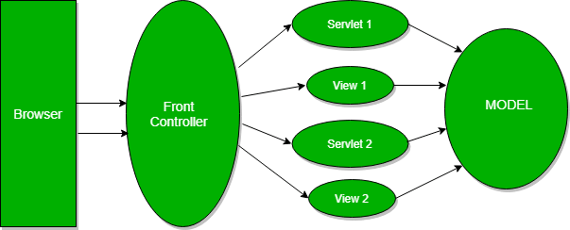](https://www.baeldung.com/wp-content/uploads/2018/12/front_end_controller.png)

### ****Q17. What Are Model 1 and Model 2 Architectures?****

Model 1 and Model 2 represent two frequently used design models when it comes to designing Java Web Applications.

**In Model 1, a request comes to a servlet or JSP where it gets handled**. The servlet or the JSP processes the request, handles business logic, retrieves and validates data, and generates the response:

[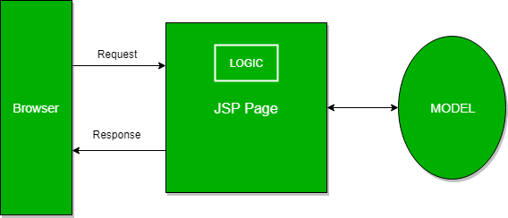](https://www.baeldung.com/wp-content/uploads/2018/12/Model_1-1.png)

Since this architecture is easy to implement, we usually use it in small and simple applications.

On the other hand, it isn't convenient for large-scale web applications. The functionalities are often duplicated in JSPs where business and presentation logic are coupled.

**The Model 2 is based on the Model View Controller design pattern and it separates the view from the logic that manipulates the content.**

**Furthermore, we can distinguish three modules in the MVC pattern: the model, the view, and the controller**. The model is representing the dynamic data structure of an application. It's responsible for the data and business logic manipulation. The view is in charge of displaying the data, while the controller serves as an interface between the previous two.

In Model 2, a request is passed to the controller, which handles the required logic in order to get the right content that should be displayed. The controller then puts the content back into the request, typically as a JavaBean or a POJO. It also decides which view should render the content and finally passes the request to it. Then, the view renders the data:

[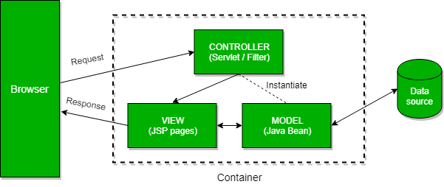](https://www.baeldung.com/wp-content/uploads/2018/12/Model_2.png)

## -----------------------------------------X--------------------------------------------

### ****Q18. What’s the Difference Between****@Controller****,****@Component****,****@Repository,****and****@Service****Annotations in Spring?****

According to the official Spring documentation, @Component is a generic stereotype for any Spring-managed component. @Repository, @Service, and @Controller are specializations of @Component for more specific use cases, for example, in the persistence, service, and presentation layers, respectively.

Let's take a look at specific use cases of last three:

* **@Controller** – indicates that the class serves the role of a controller, and detects @RequestMapping annotations within the class
* **@Service** – indicates that the class holds business logic and calls methods in the repository layer
* **@Repository** – indicates that the class defines a data repository; its job is to catch platform-specific exceptions and re-throw them as one of Spring’s unified unchecked exceptions

-------------------------------------X-----------------------------------------

### ****Q19. What Are****DispatcherServlet****and****ContextLoaderListener****?****

Simply put, in the Front Controller design pattern, a single controller is responsible for directing incoming HttpRequests to all of an application’s other controllers and handlers.

**Spring’s DispatcherServlet implements this pattern and is, therefore, responsible for correctly coordinating the HttpRequests to the right handlers.**

On the other hand, ContextLoaderListener starts up and shuts down Spring’s root WebApplicationContext. It ties the lifecycle of ApplicationContext to the lifecycle of the ServletContext. We can use it to define shared beans working across different Spring contexts.

For more details on DispatcherServlet, please refer [to this tutorial](https://www.baeldung.com/spring-dispatcherservlet).

### ****Q20. What Is a****MultipartResolver****and When Should We Use It?****

**The MultipartResolver interface is used for uploading files**. The Spring framework provides one MultipartResolver implementation for use with Commons FileUpload and another for use with Servlet 3.0 multipart request parsing.

Using these, we can support file uploads in our web applications.

---------------------------------------X---------------------------

### ****Q21. What Is Spring MVC Interceptor and How to Use It?****

Spring MVC Interceptors allow us to intercept a client request and process it at three places – before handling, after handling, or after completion (when the view is rendered) of a request.

The interceptor can be used for cross-cutting concerns and to avoid repetitive handler code like logging, changing globally used parameters in Spring model, etc.

### Q22. What Is an Init Binder?

**A method annotated with @InitBinder is used to customize a request parameter, URI template, and backing/command objects**. We define it in a controller and it helps in controlling the request.**In this method, we register and configure our custom PropertyEditors, a formatter, and validators**.

The annotation has the ‘value‘ element. If we don't set it, the @InitBinder annotated methods will get called on each HTTP request. If we set the value, the methods will be applied only for particular command/form attributes and/or request parameters whose names correspond to the ‘value‘ element.

**It's important to remember that one of the arguments must be WebDataBinder.** Other arguments can be of any type that handler methods support except for command/form objects and corresponding validation result objects.

----------------------------------X---------------------------------------

### Q23. Explain a Controller Advice

**The @ControllerAdvice annotation allows us to write global code applicable to a wide range of controllers**. We can tie the range of controllers to a chosen package or a specific annotation.

By default, **@ControllerAdvice applies to the classes annotated with @Controller (or @RestController)**. We also have a few properties that we use if we want to be more specific.

**If we want to restrict applicable classes to a package, we should add the name of the package to the annotation**:

@ControllerAdvice("my.package")

@ControllerAdvice(value = "my.package")

@ControllerAdvice(basePackages = "my.package")

It's also possible to use multiple packages, but this time we need to use an array instead of the String.

**Besides restricting to the package by its name, we can do it by using one of the classes or interfaces from that package**:

@ControllerAdvice(basePackageClasses = MyClass.class)

The ‘assignableTypes‘ element applies the @ControllerAdvice to the specific classes, while ‘annotations‘ does it for particular annotations.

**It's noteworthy to remember that we should use it along with @ExceptionHandler**. This combination will enable us to configure a global and more specific error handling mechanism without the need to implement it every time for every controller class.

### --------------------------------X-------------------------------------

### Q24. What Does the @ExceptionHandler Annotation Do?

**The @ExceptionHandler annotation allows us to define a method that will handle the exceptions**. **We may use the annotation independently, but it's a far better option to use it together with the @ControllerAdvice.** Thus, we can set up a global error handling mechanism. **In this way, we don't need to write the code for the exception handling within every controller**.

Let's take a look at the example from our article about [Error Handling for REST with Spring](https://www.baeldung.com/exception-handling-for-rest-with-spring):

@ControllerAdvice

**public** **class** **RestResponseEntityExceptionHandler**

**extends** **ResponseEntityExceptionHandler** {

@ExceptionHandler(value = { IllegalArgumentException.class,

IllegalStateException.class })

**protected** ResponseEntity<Object> **handleConflict**(RuntimeException ex,

WebRequest request) {

String bodyOfResponse = "This should be application specific";

**return** handleExceptionInternal(ex, bodyOfResponse, **new** HttpHeaders(),

HttpStatus.CONFLICT, request);

}

}

We should also note that this will provide @ExceptionHandler methods to all controllers that throw IllegalArgumentException or IllegalStateException. The exceptions declared with @ExceptionHandler should match the exception used as the argument of the method. Otherwise, the exception resolving mechanism will fail at runtime.

**One thing to keep in mind here is that it's possible to define more than one @ExceptionHandler for the same exception. We can't do it in the same class though since Spring would complain by throwing an exception and failing on startup.**

On the other hand, **if we define those in two separate classes, the application will start, but it'll use the first handler it finds, possibly the wrong one**.

-----------------------------------X-----------------------------------------

### Q25. Exception Handling in Web Applications

We have three options for exceptions handling in Spring MVC:

* per exception
* per controller
* globally

If an unhandled exception is thrown during web request processing, the server will return an HTTP 500 response. To prevent this, **we should annotate any of our custom exceptions with the @ResponseStatus annotation**. **This kind of exceptions is resolved by HandlerExceptionResolver**.

This will cause the server to return an appropriate HTTP response with the specified status code when a controller method throws our exception. We should keep in mind that we shouldn't handle our exception somewhere else for this approach to work.

**Another way to handle the exceptions is by using the @ExceptionHandler annotation**. We add @ExceptionHandler methods to any controller and use them to handle the exceptions thrown from inside that controller. These methods can handle exceptions without the @ResponseStatus annotation, redirect the user to a dedicated error view, or build a totally custom error response.

We can also pass in the servlet-related objects (HttpServletRequest, HttpServletResponse, HttpSession, and Principal) as the parameters of the handler methods. But, we should remember that we can't put the Model object as the parameter directly.

**The third option for handling errors is by @ControllerAdvice classes**. It'll allow us to apply the same techniques, only this time at the application level and not only to the particular controller. To enable this, we need to use the @ControllerAdvice and the @ExceptionHandler together. This way exception handlers will handle exceptions thrown by any controller.

\*\*\*\*\*\*\*\*\*\*\*\*\*\*What is difference between Spring Jpa and Spring Data JPA\*\*\*\*\*\*\*\*

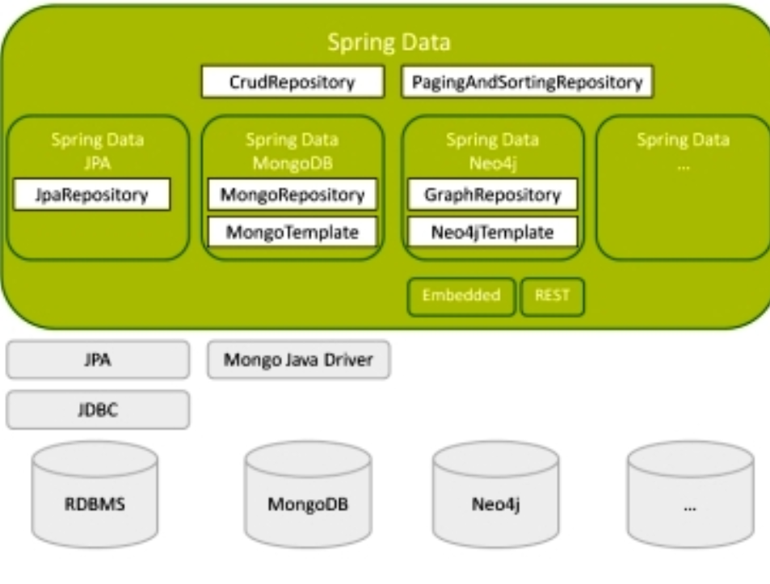

**\*\*\*\*\*\*\*\*\*\*\*\*What is HazleCast In Spring Boot Data JPA\*\*\*\*\*\*\*\*\*\***

**What is caching:**

It is a temporary memory that lies between the application and the persistent database. Cache memory stores recently used data(in case of LRU) in order to reduce the number of database hits as much as possible.

**What is hazelcast:**

Hazelcast is an open source caching solution which is often used as an operation memory layer for databases in order to improve performance of applications, to distribute data across servers, clusters and geographies, to ingest data at very high rates, and to manage large data sets.

It is written in Java, so by default multi-threaded.

**What we will build in this example:**

We will use spring boot and spring data JPA for DB operations. H2 DB will be used as database and hazelcast as a cache provider. When we get data from database we will store it in cache memory. So from second time onwards, our front end reqeuests don’t hit the DB and get data from cache memory.

**Our Project in Detail:**

**pom.xml**

<dependency><groupId>org.springframework.boot</groupId><artifactId>spring-boot-starter-cache</artifactId></dependency><dependency><groupId>com.hazelcast</groupId><artifactId>hazelcast</artifactId></dependency><dependency><groupId>com.hazelcast</groupId><artifactId>hazelcast-spring</artifactId></dependency>

We will use the first dependency to add spring cache and other two to add hazelcast to our spring boot project. You can check other dependecies in the github link that is provided at the end of this article.

In main class, we will use **@EnableCaching** which enables Spring’s annotation-driven cache management capability

Now we will configure hazelcast in our project.

***HazelcastConfiguration.java***

@Configurationpublic class HazelcastConfiguration {@Beanpublic Config hazelCastConfig(){return new Config().setInstanceName(“hazelcast-instance”).addMapConfig(new MapConfig().setName(“users-cache”).setMaxSizeConfig(new MaxSizeConfig(200, MaxSizeConfig.MaxSizePolicy.FREE\_HEAP\_SIZE)).setEvictionPolicy(EvictionPolicy.LRU).setTimeToLiveSeconds(200));}}

To create a named HazelcastInstance you should set instanceName of Config object which is **hazelcast-instance** in our case.

To retrieve an existing HazelcastInstance using its name, use;

Hazelcast.getHazelcastInstanceByName('hazelcast-instance');

To retrieve all existingHazelcastInstances, use;

Hazelcast.getAllHazelcastInstances();

We will create a new MapConfig() with name **users-cache**which can be used in services to manipulate cache data

setMaxSizeConfig() — Configuration for map’s capacity. You can set a limit for number of entries or total memory cost of entries.

setEvictionPolicy() — We will use an cache eviction algorithm is a way of deciding which element to evict when the cache is full. In this example, we are using LRU. we can also use LFU.

setTimeToLiveSeconds() — is the maximum number of seconds for each entry to stay in the map.

***User Entity Class***

Integer id;String name;String contact;

***UserDAO inteface for Spring Data JPA operation***

public interface UserDAO extends CrudRepository<User, Integer>{}

***Service Class***

@Servicepublic class UserService {@Autowiredprivate UserDAO userDAO;@Cacheable(value=”users-cache”, key=”#userId”, unless = “#result==null”)public Optional<User> getUserById(Integer userId) {return userDAO.findById(userId);}@CacheEvict(value=”users-cache”, key=”#userId”)public void deleteUser(Integer userId) {userDAO.deleteById(userId);}@CachePut(value=”users-cache”)public User updateUser(User user) {User updatedUser = null;int id = user.getId();User userFromDB = userDAO.findById(id).orElse(null);if(userFromDB != null) {userFromDB.setName(“Go Jek”);userFromDB.setContact(“4444”);updatedUser = userDAO.save(userFromDB);}return updatedUser;}}

In service layer, we will use “**users-cache**” to work on this cache. We have specified this in our configuration.We will use below annotation to work on caching.

@Cacheable - Each time an advised method is invoked, caching behavior will be applied, checking whether the method has been already invoked for the given arguments.If no value is found in the cache for the computed key, the target method will be invoked and the returned value stored in the associated cache.@CacheEvict - cache eviction operation@CachePut - update cache